**WATER BORNE DISEASE PREDICTION IN A PARTICULAR LOCATION**

**A PROJECT REPORT**

***Submitted by,***

**Ms. ARYA M R                - 20201CAI0184**

**Ms. NIKHITHA V            - 20201CAI0189**

**Ms. MANISHA G             - 20201CAI0191**

**Ms. NIHARIKA N LAD   - 20201CAI0194**

***Under the guidance of,***

**Dr. C KOMALAVALLI**

***in partial fulfillment for the award of the degree of***

**BACHELOR OF TECHNOLOGY**

**IN**

**COMPUTER SCIENCE AND ENGINEERING**

**(ARTIFICIAL INTELLIGENCE AND MACHINE LEARNING)**

**At**



**PRESIDENCY UNIVERSITY**

**BENGALURU**

**JANUARY 2024**

**PRESIDENCY UNIVERSITY**

**SCHOOL OF COMPUTER SCIENCE AND ENGINEERING**

**CERTIFICATE**

This is to certify that the Project report **“WATER BORNE DISEASE PREDICTION IN A PARTICULAR LOCATION”** being submitted by “ARYA M.R, NIKHITHA V, MANISHA G, NIHARIKA N LAD” bearing roll number(s) “20201CAI0184, 20201CAI0189, 20201CAI0191, 20201CAI0194” in partial fulfilment of requirement for the award of degree of Bachelor of Technology in Computer Science and Engineering

(Artificial Intelligence and Machine Learning) is a Bonafide work carried out under my supervision.

|  |  |
| --- | --- |
| **Dr C Komalavalli**  Professor  School of CSE  Presidency University | **Dr. Zafar Ali Khan N**  Associate Professor & HoD  School of CSE  Presidency University |

|  |  |  |
| --- | --- | --- |
| **Dr. C. KALAIARASAN**  Associate Dean  School of CSE&IS  Presidency University | **Dr. SHAKKEERA L**  Associate Dean  School of CSE&IS  Presidency University | **Dr. SAMEERUDDIN KHAN** Dean  School of CSE  Presidency University |

**PRESIDENCY UNIVERSITY**

**SCHOOL OF COMPUTER SCIENCE AND ENGINEERING**

**DECLARATION**

We hereby declare that the work, which is being presented in the project report entitled **WATER BORNE DISEASE PREDICTION IN A PARTICULAR LOCATION** in partial fulfilment for the award of Degree of **Bachelor of Technology** in **Computer Science and Engineering**

**(Artificial Intelligence and Machine Learning)**, is a record of our own investigations carried out under the guidance of supervisor

**DR. C KOMALAVALLI, Professor,** **School of Computer Science and Engineering, Presidency University, Bengaluru.**

We have not submitted the matter presented in this report anywhere for the award of any other Degree.

|  |  |  |
| --- | --- | --- |
| **Arya M R**  **Nikhitha V**  **Manisha G**  **Niharika N Lad** | **20201CAI0184**  **20201CAI0189**  **20201CAI0191**  **20201CAI0194** |  |

**ABSTRACT**

Waterborne pathogens pose a threat to public health and assessing disease risk requires accurate measurements of pathogens in contaminated water. To solve this problem, a community driven project has launched a new website that implements artificial intelligence (AI) and machine learning (ML) to provide better information about water quality and pollution, with a focus on aquatic life. This new practice is designed to improve early detection of the disease, education, data collection and public engagement, ultimately leading to advances in public health and surveillance of the disease.   
At the heart of the program is a commitment to comprehensive needs assessment leading to the rapid development of consumer products in high technology related businesses. Geotagging, cloud infrastructure, and disease specific modules are intricately woven into the fabric of the application to provide a holistic approach to water quality assessment. Leveraging the power of artificial intelligence and machine learning, the application provides an effective platform for monitoring and predicting waterborne diseases, providing important tools for healthcare professionals, clean society and policy makers.   
An important aspect of the practice is its emphasis on public participation. Through interactive features and real-time data visualization, communities can participate in monitoring water quality. This two-way communication fosters a sense of unity and community leadership. Additionally, the integration of geotagging technology allows users to contribute location-specific information, creating a comprehensive and comprehensive database.   
The expected benefits of this community support are far-reaching. Through implementation, waterborne diseases can be effectively reduced, public health services improved, epidemics better responded to, and public awareness of water quality issues increased. The initiative is an important step towards integrating technology into public health assessment, providing decision-makers with accurate and timely information for strategic planning, preventive measures and civil protection.   
All in all, this community support represents a revolution in the use of technology to solve the problem of waterborne diseases. Through the integration of artificial intelligence, machine learning, and community engagement, the web application demonstrates technology's potential to improve health outcomes for the public by providing large-scale, flexible solutions for the world's water security and disease prevention efforts.

Keywords:Waterborne disease, health, machine learning, outbreak, monitoring

**ACKNOWLEDGEMENT**

First of all, we indebted to the **GOD ALMIGHTY** for giving me an opportunity to excel in our efforts to complete this project on time.

We express our sincere thanks to our respected dean

**Dr. Md. Sameeruddin Khan**, Dean, School of Computer Science and Engineering and School of Information Science, Presidency University for getting us permission to undergo the project.

We record our heartfelt gratitude to our beloved Associate Deans

**Dr. Kalaiarasan C and Dr. Shakkeera L,** School of Computer Science and Engineering and Information Science, Presidency University and

**Dr. Zafar Ali Khan N**, Head of the Department, School of Computer Science and Engineering, Presidency University for rendering timely help for the successful completion of this project.

We are greatly indebted to our guide **Dr. C Komalavalli, Professor**, School of Computer Science and Engineering, Presidency University for her inspirational guidance, valuable suggestions and providing us a chance to express our technical capabilities in every respect for the completion of the project work.

We would like to convey our gratitude and heartfelt thanks to the University Project-II Coordinators **Dr. Sanjeev P Kaulgud, Dr. Mrutyunjaya MS** and also the department Project Coordinators **Dr. Murali Paremeswaran**.

We thank our family and friends for the strong support and inspiration they have provided us in bringing out this project.

**Arya M R**

**Nikhitha V**

**Manisha G**

**Niharika N Lad**

**LIST OF TABLES**

|  |  |  |  |
| --- | --- | --- | --- |
| **Sl. No.** | **Table Name** | **Table Caption** | **Page No.** |
| 1 | Table 1.1 | Types of water borne disease | 2 |
| 2 | Table 2.1 | Literature Review | 9 |
| 3 | Table 7 | The timeline of the project | 29 |

**LIST OF FIGURES**

|  |  |  |  |
| --- | --- | --- | --- |
| **Sl. No.** | **Figure Name** | **Caption** | **Page No.** |
| 1 | Figure 1.1 | Most waterborne diseases in India | 2 |
| 2 | Figure 6.4.2 | Density v/s nature of the water. | 27 |
| 3 | Figure 6.4.3 | People with a particular water borne disease | 27 |
| 4 | Figure 6.5 | Sequence diagram of the model | 28 |

**TABLE OF CONTENTS**

|  |  |  |
| --- | --- | --- |
| **CHAPTER NO.** | **TITLE** | **PAGE NO.** |
|  | **ABSTRACT**  **ACKNOWLEDGMENT** | **IV**  **V** |
| **1.** | **INTRODUCTION** | 1 |
|  | 1.1 WATER BORNE DISEASES | 1 |
|  | 1.2 CAUSES OF WATER BORNE DISEASES | 1 |
|  | 1.2.1 Human Activities And pollution | 2 |
|  | 1.2.2 Microbial Contamination | 3 |
|  | 1.2.3 Poor Water Treatment | 3 |
|  | 1.2.4 Environmental dynamics | 3 |
|  | 1.2.5 Inadequate sanitary facilities | 3 |
|  | 1.3 EXPLANATION FROM THREAT OF WATER | 4 |
|  | 1.4 ECHOS OF POLLUTION: TRACING OF ROOTS | 4 |
|  | 1.5 BEYOND ILLNESS: MANY CAUSES | 4 |
|  | 1.6 DANCE OF THE WATER SECURITY AND SAFETY | 6 |
| **2.** | **LITERATURE REVIEW** | **7** |
| **3.** | **RESEARCH GAPS** | **13** |
| **4.** | **PROPOSED METHODOLOGY** | **15** |
| **5.** | **OBJECTIVES** | **17** |
|  | 5.1 EARLY DETECTION OF DISEASES | 17 |
|  | 5.2 LOCATION MAP | 17 |
|  | 5.3 INFORMATION SHARING | 17 |
|  | 5.4 REAL TIME ALERTS | 18 |
|  | 5.5 PUBLIC PARTICIPATION | 18 |
|  | 5.6 SUSTAINABLE DEVELOPMENT | 18 |
|  | 5.7 PUBLIC AWARENESS | 19 |
|  | 5.8 RESULTS | 19 |
| **6.** | **SYSTEM DESGIN AND IMPLEMENTATION** | **20** |
|  | 6.1 **FUNCTIONAL REQUIREMENTS** | 20 |
|  | 6.1.1 Creating Good Water Management | 20 |
|  | 6.1.2 Data Processing Algorithms | 20 |
|  | 6.1.3 Intuitive Mobile API | 20 |
|  | 6.1.4 Mapping Tools | 20 |
|  | 6.1.5 Alarm system | 21 |
|  | 6.1.6 Secure User Authentication | 21 |
|  | 6.1.7Repository | 21 |
|  | 6.2 NON-FUNCTIONAL REQUIREMENTS | 22 |
|  | 6.2.1 Features | 22 |
|  | 6.2.2Performance | 22 |
|  | 6.2.3Supportability | 22 |
|  | 6.3 ALGORITHMS | 22 |
|  | 6.3.1 Random Forest Classifier | 22 |
|  | 6.3.2 Ensemble Learning | 23 |
|  | 6.3.3 Deciphering Data Distribution | 23 |
|  | 6.3.4 Central Tendency Measures | 24 |
|  | 6.3.5 Performance Parameters | 24 |
|  | 6.3.5.1 Accuracy | 24 |
|  | 6.3.5.2 Precision | 24 |
|  | 6.3.5.3 Recall | 24 |
|  | 6.3.5.4 F1 Score | 25 |
|  | 6.3.6 Advantages of algorithm | 26 |
|  | 6.3.7 Disadvantages of algorithm | 26 |
|  | 6.4 SOFTWARE REQUIREMENTS | 27 |
|  | 6.4.1 Operating System | 27 |
|  | 6.4.2 Coding Language | 27 |
|  | 6.4.3Integrated Development Environment | 27 |
|  | 6.5 DATA FLOW DIAGRAM | 29 |
| **7** | **TIMELINE OF THE PROJECT** | **30** |
| **8** | **OUTCOMES** | **32** |
| **9** | **RESULTS AND DISCUSSIONS** | **33** |
|  | 9.1 TECHNICAL PERFORMANCE | 33 |
|  | 9.1.1 Accuracy Metrics | 33 |
|  | 9.1.2 Evaluating Educational Standards | 33 |
|  | 9.2 REAL WORLD IMPLICATIONS | 33 |
|  | 9.2.1 Reduces the incidence of disease | 33 |
|  | 9.2.2 Improving Public Health Monitoring | 33 |
|  | 9.2.3 Effective Outbreak Response | 34 |
|  | 9.2.4 Healthcare Cost Reduction | 34 |
|  | 9.3 USER PARTICIPATION AND COMMUNITY DEVELOPMENT | 34 |
|  | 9.3.1 Raise Public Awareness | 34 |
|  | 9.3.2 Developing the community | 34 |
|  | 9.4 CHALLENGES AND FUTURE DIRECTION | 34 |
|  | 9.4.1 Algorithm Fine-Tuning | 34 |
|  | 9.4.2 User Interface Enhancements | 34 |
|  | 9.4.3 Community Feedback Integration | 35 |
| **10** | **CONCLUSION** | **37** |
|  | **REFERENCES** | **40** |
|  | **APPENDIX-A** | **42** |
|  | **APPENDIX-B** | **47** |
|  | **APPENDIX-C** | **56** |

**CHAPTER-1**

**INTRODUCTION**

* 1. **Waterborne Diseases:**

Progress in our developing world is the dynamic and definition of a healthy community in access to clean and safe water. But there is a conflicting note in the symphony of progress: the looming threat of disease from water. Knowledge of their local spread is not only desirable; This is urgent to protect public health. Our service works like an ever-vigilant digital messenger to protect public health. This is more than just an app; It is an initiative that provides important insight into the complexity of waterborne diseases and provides a powerful defense mechanism for the health of our communities.

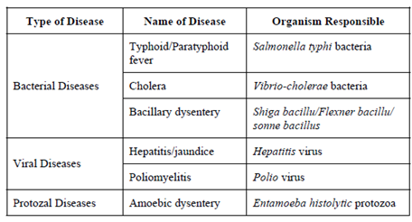

Table 1.1 Types of water borne disease

* 1. **Causes of Waterborne Diseases:**

Our initiative transcends the digital world and becomes a community-focused movement; A concerted effort to protect neighbors and their loved ones from waterborne illnesses is not easy, but the insidious effects of waterborne diseases are. infection. Bacteria in water. As a fundamental responsibility, we want people to have

the information and resources they need to make informed decisions about water quality. This move transforms the app's passive role into a dynamic digital monitor. It not only provides an overview of waterborne diseases, but also uses state-of-the-art testing to contribute to the safety of our communities. In fact, it embodies the spirit of community-driven resilience that resonates with the collective strength that must confront the challenges posed by water threats.

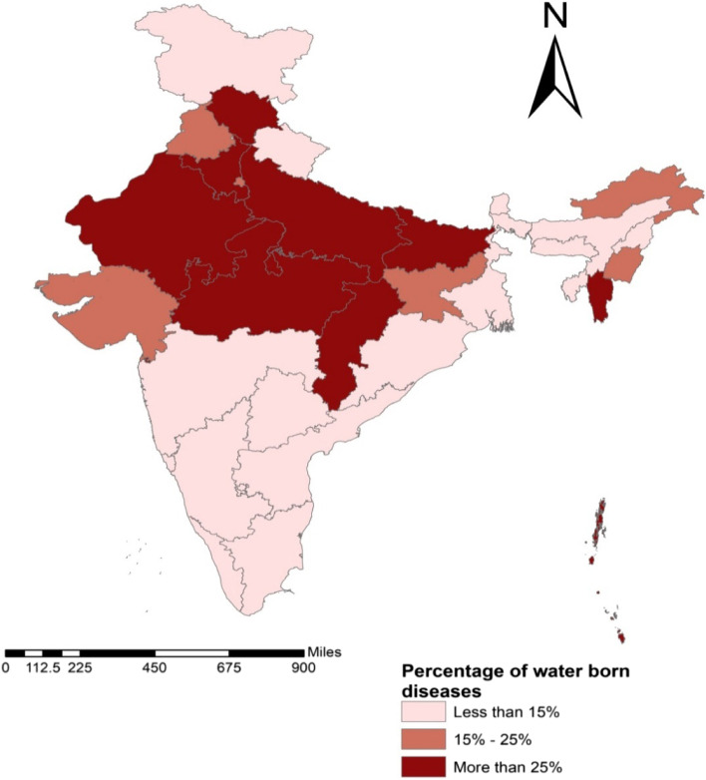

Fig 1.1: Most waterborne diseases among adults spread across Indian states

* + 1. **Human Activities and Pollution:**

One of the main causes of waterborne diseases is the result of human labor and pollution. Urban industry, industrial emissions and agriculture cause water pollution, creating a favorable environment for the spread of disease-causing organisms. Understanding and addressing human factors that contribute to water pollution are important steps in strengthening our defenses against waterborne diseases.

* + 1. **Microbial contamination:**

Microbiological contamination is an important factor in waterborne diseases. illness. Pathogenic organisms, including bacteria, viruses, and fungi, can enter the water supply due to inadequate sanitation and wastewater treatment. Uncontrolled microbial contamination can lead to infectious diseases such as cholera, giardiasis and norovirus. Careful monitoring and reduction of microbial contamination is important for public health and prevention.

* + 1. **Poor water treatment:**  
       Poor water treatment plays a significant role in the spread of waterborne diseases. illness. Inadequate or ineffective water treatment allows diseases to spread, putting communities at health risk. Improving water purification systems and ensuring tight control are important steps in turning our digital services into strong defenses against poor water quality and related diseases.
    2. **Environmental Dynamics:**  
       Environmental dynamics, including events such as climate change and extreme weather conditions, increase the complexity of aquatic organisms. Changing weather conditions, changes in temperature and precipitation can affect the quality of water, creating the perfect environment for bacteria to thrive. Acknowledging and adapting to these environmental changes is crucial to improving our defenses against changing landscapes with water challenges.
    3. **Inadequate sanitary facilities:**  
       Inadequate sanitary facilities are the cause of environmental pollution. Bacteria in water. If human waste is disposed of or untreated improperly, it can contaminate water and spread diseases such as dysentery and typhoid. Promoting and implementing good practice is an important step in our community-focused campaign to address the root causes of waterborne diseases.

Because waterborne diseases have many causes, understanding and addressing each input is important to developing a solution. Peace and protection against threats to our communities.

* 1. **Explanation of the Threat from Water:**

We set out on an adventure towards the invisible danger in the water, to reveal the threatened microscopic world of water. This is a gripping investigation that reveals the hidden journeys and demise of diseases that work together to disrupt the balance of health. This is an illuminating dive into a hidden space where microbial communities have a significant impact, revealing their impact on the health of our water.

* 1. **Echoes of Pollution: Tracing the Roots:**

Under the seemingly emotional water, the principle of combating pollution is to deeply understand the roots of waterborne diseases. This chapter highlights the complex causes of waterborne diseases and explores the interaction between human activities and environmental quality. It seeks to trace the origins of pollution to understand its serious impact on the health of our water resources.

* 1. **Beyond Illness: Many Causes**

Illness in water is not an explanation but there are many myths that many actors can be on stage. This article expands our understanding by understanding the various culprits (bacteria, viruses, etc.) that lead to the definition of waterborne diseases. It expands the theory and reveals the web of interconnected interactions that form the landscape of aquatic health problems.

* 1. **The Dance of Water Safety and Security:**

In a fascinating dance, roads and safety come together to solve the many problems caused by the water threat. These chapters illustrate the complex steps involved in the nuances of environmental change and climate, revealing vulnerabilities and their impacts on public health. It is a description of empowerment where the safety and security of society becomes a contribution in response to the complexity of water risk.

In this world where the digital frontier meets public health, our services represent a beacon, a beacon for healthcare, raising awareness and ultimately improving public health.

**CHAPTER-2**

**LITERATURE REVIEW**

|  |  |  |  |  |
| --- | --- | --- | --- | --- |
| **Sl.no** | **Paper Name** | **Author** | **Journal Name** | **Observation** |
| 1. | **“ A Rule-based Diagnosis of Water-Borne Diseases: A Benchmark for Future Intelligent System Development”.** | Goldah Grace D. Sultan, Florence Jean B. Talirongan, Markdy Y. Orong, Hidear Talirongan | Middle East Journal of Applied Science & Technology | The study presents a computer  -based algorithm in E-Doctor for diagnosing eight waterborne diseases, providing an efficient alternative for general practitioners and health-conscious individuals. Successful disease identification highlights its potential, while recommendations for scope expansion and Fuzzy expert system implementation ensure a comprehensive approach for community-wide diagnosis. |
| 2. | **“Ensemble Machine Learning Model to Predict the Waterborne Syndrome”** | Mohammed Gollapalli | Special Issue Algorithms for Feature Selection | The study employs a machine learning model, achieving 98.90% accuracy, addressing waterborne diarrhea challenges. Outcomes guide post-COVID-19 health strategies in low-income nations, emphasizing prevention. |
| 3 | **“Machine learning based efficient prediction of positive cases of waterborne diseases”.** | Mushtaq Hussain, Mehmet Akif Cifci, Tayyaba Sehar, Said Nabi, Omar Cheikhrouhou, Hasaan Maqsood, Muhammad Ibrahim ,Fida Mohammad | BMC Medical Informatics and Decision Making | This study on waterborne diseases in Pakistan employs machine learning models, with Random Forest achieving 60% accuracy for malaria and 77% for typhoid. Significant features include age, history, and test results, informing future efforts for improved prediction and decision-making in healthcare. |
| 4 | **“The Quality of Drinkable Water using Machine Learning Techniques”.** | Osim Kumar Pal | ResearchGate  Nets | This study employs five machine learning algorithms to predict drinking water quality, providing a quicker alternative to conventional laboratory methods. Achieving high accuracy, particularly with Artificial Neural Network (ANN) at 99%, the model contributes to effective water management and prevention of waterborne diseases. Future implementations include analyzing drinking water quality in diverse regions using an IoT-based detection system. |

|  |  |  |  |  |
| --- | --- | --- | --- | --- |
| 5 | **“Scalable and accurate deep learning with electronic health records”.** | Alvin Rajkomar, Eyal Oren, Kai Chen, Andrew M. Dai, Nissan Hajaj, Michaela Hardt, Peter J. Liu, Xiaobing Liu, Jake Marcus, Mimi Sun, Patrik Sundberg, Hector Yee,. | npj Digital Medicine journal | Predictive modeling with FHIR-formatted EHR data using deep learning achieves high accuracy. Despite success, challenges include applying models across sites and understanding the incremental contribution of clinical notes. |
| 6 | **“A study of waterborne diseases during flooding using Radarsat-2 imagery and**  **back propagation**  **neural network algorithm”.** | Peera Yomwan, Chunxiang Cao, Preesan Rakwatin, Warawut Suphamitmongkol, Rong Tian &Apitach Saokarn. | Taylor and Francis Online journals | the study's innovative use of the BPNN technique, based on simple parameters, demonstrates a highly accurate and efficient approach for predicting the risk of diarrhea outbreaks in flood-affected areas. This method offers a valuable tool for timely decision-making in public health and disaster management. |
| 7 | **“Opportunities and obstacles for deep learning in biology and medicine”.** | Travers Ching†, Daniel S. Himmelstein, Brett K. Beaulieu-Jones, Alexandr A. Kalinin, Brian T. Do, Gregory P. Way, Enrico Ferrero, Paul-Michael Agapow, Michael Zietz, Michael M. Hoffman. | Journal of The Royal Society Interface | Deep learning excels in biomedical tasks, notably medical imaging, with human-level performance. Challenges include imperfect accuracy, susceptibility to mistakes, and privacy concerns. Ongoing research aims to address these, highlighting its evolving potential in biology and medicine. |
| 8 | **“MIMIC-III, a freely accessible critical care database”.** | Travers Ching†, Daniel S. Himmelstein, Brett K. Beaulieu-Jones, Alexandr A. Kalinin, Brian T. Do, Gregory P. Way, Enrico Ferrero, Paul-Michael Agapow, Michael Zietz, Michael M. Hoffman . | Scientific data journal | The initiative aims to foster collaborative and iterative development in critical care research by providing a shared code repository . The repository, initially populated with code for calculating critical care variables, invites researchers to contribute, enhancing its value over time. Additionally, standardized clinical ontologies aim to enhance integration with diverse datasets and facilitate generalized analytic tools |
| 9 | **“Identifying Medical Diagnoses and Treatable Diseases by Image-Based Deep Learning”.** | Travers Ching†, Daniel S**.** Himmelstein, Brett K. Beaulieu-Jones, Alexandr A. Kalinin, Brian T. Do, Gregory P. Way, Enrico Ferrero, Paul-Michael Agapow, Michael Zietz, Michael M. Hoffman. | Cell journals | This study introduces a versatile AI platform for diagnosing diabetic macular edema, showcasing competitive performance in OCT image analysis without requiring specialized deep-learning machinery or extensive image databases. The transfer learning |
| 10 | **“Prevalence of Mental Disorders and Addictions among Homeless People in the Greater Paris Area”, France** | [Anne Laporte](https://sciprofiles.com/profile/359979?utm_source=mdpi.com&utm_medium=website&utm_campaign=avatar_name), [Stéphanie Vandentorren](https://sciprofiles.com/profile/359939?utm_source=mdpi.com&utm_medium=website&utm_campaign=avatar_name) ,[Marc-Antoine Détrez](https://sciprofiles.com/profile/360436?utm_source=mdpi.com&utm_medium=website&utm_campaign=avatar_name), [Caroline Douay](https://sciprofiles.com/profile/author/cXo0TExmKy9XZkZpbTVZTHhRQ0NZVHg2bWdmRmpBeW5tUmhWaklpbzh0az0=?utm_source=mdpi.com&utm_medium=website&utm_campaign=avatar_name), [Yann Le Strat](https://sciprofiles.com/profile/author/UTNCY2lDMHNmQzFpR1cxNUs0V0ptKzIyd0s3SU8zT2JKODk2Yzk5M01xRT0=?utm_source=mdpi.com&utm_medium=website&utm_campaign=avatar_name), [Erwan Le Méner](https://sciprofiles.com/profile/author/cVM4bVJZOVkwT3F1L2pFT3k1bnJKdS9HQjZDSlVweENSSGN5aFRvMThtYz0=?utm_source=mdpi.com&utm_medium=website&utm_campaign=avatar_name), [Pierre Chauvin](https://sciprofiles.com/profile/359858?utm_source=mdpi.com&utm_medium=website&utm_campaign=avatar_name). | MDPI journals | The 2009 Samenta study in Greater Paris assessed psychiatric disorders in homeless individuals, revealing one-third had severe psychiatric disorders. Findings underscore the need for improved detection, housing, and care, urging a follow-up survey to address the worsening situation, particularly focusing on minors and non-French speakers. |

Table 2.1: Literature Review.

This literature review on disease detection through monitoring of waterborne diseases explores the wealth of previous research and existing solutions in this field, public health, disease surveillance, and technological interventions. The work of scholars, historical texts, and research into technological developments provide a framework for understanding the current landscape and identifying gaps such that implementation needs to be unraveled.

Many studies have demonstrated the importance of real-time data in disease surveillance. Rapid collection, analysis and dissemination of information during an outbreak is one issue. Current systems, although effective, often face challenges related to business information, usability, and coordination. These findings serve as background and practice to highlight the importance of timely collection and dissemination of information that can be understood as a response to these deficiencies.

The document also reveals the changing role of technology in public health. Mobile applications, in particular, have become powerful tools for disease surveillance and health education. The success of similar applications in different contexts demonstrates the feasibility and effectiveness of leveraging technology in solving public health problems. A literature review examines these models to provide insight into the features and functions that contribute to the success of these applications.

The editorial policy should be the basis of the application, supported by research demonstrating the importance of gathering information. Differences have emerged in disease reporting procedures, highlighting the need for harmonization and the need to ensure that all

relevant information is included. Data analysis therefore works in principle and proves the concept of the application in the general context of virus reporting and monitoring systems.

Also, spatial data discovery and GIS technology are emerging in disease monitoring. as a recurring theme. The ability to identify disease hotspots, track areas of disease, and allocate resources efficiently is a major focus of recent research. The literature review evaluates the impact of spatial intelligence on disease control and identifies the potential contribution of location to the app's reporting capacity.

In combining these predictions, data analysis is performed to improve the application. It not only recognizes the need for up-to-date information in disease monitoring, but also places applications on the path of technological developments in the field of healthcare and public health. A combination of findings from various studies informs the app's design choices and functionality, ensuring the app not only solves existing problems but also adapts to change in the public health technology landscape.

**CHAPTER-3**

**RESEARCH GAPS OF EXISTING METHODS**

Significant progress has been made in diagnosing waterborne diseases with the introduction of computer-based algorithms, machine learning models, and new technologies. These studies provide an important method for diagnosing waterborne diseases and offer an alternative method to doctors and healthcare professionals. However, among these exciting results, some research gaps also emerged that require further investigation.

A study demonstrates computer-based algorithms in E-Doctor for diagnosing eight waterborne diseases, demonstrating its population-wide diagnostic potential. While successful disease identification stands out, suggestions for expanding and using fuzzy experts point to areas requiring further research. Integrating fuzzy logic into the diagnostic process can improve adaptation to uncertain data and provide a seamless approach to disease diagnosis.

Another study used machine learning models to achieve 98.90% accuracy in diagnosing diarrheal diseases and recommending COVID-19 health strategies in low-income countries. Despite significant progress, research still needs to focus on the effectiveness of these strategies in resource-limited settings. Understanding the feasibility and effectiveness of these interventions in real-world settings is crucial to ensuring their successful implementation.

A waterborne disease study in Pakistan using machine learning models to predict malaria and typhoid highlights the importance of accurate diagnosis. However, the average accuracy achieved for this particular disease reflects scientific differences in the development of the correct model. Future efforts should explore improved models, incorporate other relevant factors, and improve diagnostic capabilities.

Another study used five machine learning algorithms to predict drinking water quality, providing a faster alternative to drug testing. Using IOT-based search engines for multi-domain analysis while achieving high accuracy is still an unexplored area. Future research should investigate the scalability and adaptability of such systems in different geographical

and cultural contexts.

Despite the success of using deep learning for modeling of EHR data in the FHIR format, issues related to the use of models from different sites present, leaving a gap in the science. Examining the generality of patterns across different clinical settings and understanding the additional support of clinical data may improve the overall applicability of predictive models.

This study demonstrates the effectiveness of deep learning by recognizing challenges such as inaccuracy and illegality in the biomedical field, especially in medicine. Ongoing research should focus on developing strategies to mitigate these issues and ensure the integrity and security of deep learning in healthcare.

Also an initiative to promote collaboration and innovation in critical care research through collaborative processes. Code repository. While laudable, research remains inconsistent in understanding the long-term impact and sustainability of such partnerships. Future research should investigate the effectiveness of collaboration, evaluate the value of data repositories, and evaluate the effectiveness of clinical ontologies.

Furthermore, this study presents a multidisciplinary artificial intelligence platform for the diagnosis of diabetic macular edema and demonstrates competition in OCT image analysis without the necessary for specialization deep learning tools or extensive image libraries. However, the difference of the research lies in investigating the development of similar platforms for other specific conditions, thus promoting the differentiation of diagnostic tools.

Finally, the 2009 Greater Paris Sarmenta Survey found serious mental health problems among the homeless. This suggests exploring gaps in the search for collaborative approaches to improving testing, housing, and care for vulnerable populations. Future research should understand effective strategies to meet the diverse needs of the homeless population, focusing on children and non-French speakers.

In summary, although existing studies praise the use of water technology for disease detection, these observations point to specific areas that need to be explored and further developed. Closing these research gaps will not only improve the accuracy and validity of diagnostic models, but will also help develop more comprehensive and inclusive healthcare solutions.

**CHAPTER-4**

**PROPOSED MOTHODOLOGY**

Water quality management is an important part of public health, and the way our model is presented brings together many new ways to solve this problem. A key part of this involves using water quality sensors to instantly measure parameters such as pH, turbidity and chlorine levels. These sensors provide continuous data generated by our comprehensive analysis. Meanwhile, geographic information system (GIS) technology shows a vital role in mapping water resources, pollution conditions and affected areas. This comprehensive view helps identify patterns and trends important for effective water management.

An important aspect of our approach is the use of random forest distribution as a machine learning algorithm. This approach uses historical data to identify patterns associated with aquatic organisms. The application can improve the ability to predict risk using predictive models and thus aid public health assessment. Additionally, user involvement is prioritized through the reporting feature that allows users to report water quality issues directly from the app. The user-friendly interface makes it easy to communicate important information such as location, symptoms and images, ensuring fast and accurate responses.

Data fusion, which combines data from different sources, including sensors, weather, and data processing issues, is used to enhance the analytical capabilities of the application. This comprehensive approach provides a comprehensive analysis of potential diseases, providing decision makers with a better understanding. Delay is important for the management of waterborne diseases and the warning system has been integrated to solve this problem. Based on application analysis, the system instantly alerts users and authorities to dangerous risks, ensuring their rapid protection.

Ensuring the accuracy of information regarding different water resources is at the heart of our model. Therefore, this approach involves monitoring and updating information on various water resources such as wells, rivers, and reservoirs. This powerful system can help provide a more comprehensive understanding of the environment by tracking changes in water quality over time.

Community engagement is at the heart of our approach, from providing water sanitation educational content to encouraging participation and emphasizing best practices and reporting. An informed and engaged community is an asset that provides greater knowledge and collective efforts to prevent waterborne diseases. In addition, integration of the application with health information and working with health systems to increase the accuracy of disease tracking is also a recommendation. Integrating water quality data and health data creates a more comprehensive view of public health.

Collaboration is essential to the success of our model, which is why we actively seek cooperation with local health authorities and environmental organizations. . Sharing information and coordinating response strategies can increase the effectiveness of your application. However, it is important to emphasize the importance of user privacy, data security and compliance with relevant regulations in the development and use of these applications. Striking the right balance between innovation and ethical considerations is critical to building trust and ensuring the long-term success of the plan.

In summary, the strategy integrates new technology and community engagement to create effective water management models. Combining real-time data, GIS maps, and random forest classification based on machine learning algorithms, our approach aims to revolutionize the way we monitor and respond to aquatic organisms. Collaboration with the medical system and authorities, privacy, and commitment to ethics make this model effective and useful for public protection health testing.

**CHAPTER-5**

**OBJECTIVES**

The important role of artificial intelligence (AI)-powered mobile health in traditional healthcare cannot be ignored. These apps are useful tools and resources for cross-medical and independent critical healthcare. Among the many problems faced by communities in this region, waterborne diseases also pose a threat to public health. The mobile health app aims to not only educate people about these waterborne diseases, but also provide early detection tools, guidance on finding appropriate treatment, and methods to track conditions over time.

* 1. **Early Detection of Diseases**

The basis of the purpose of the application is the desire to detect the disease early. The application tries to analyze the health information provided by users by leveraging the power of artificial intelligence algorithms. By identifying early symptoms at the outset, the app wants to provide users with timely reminders or advice to seek treatment quickly. This goal is based on an approach to health care that emphasizes prevention and early intervention.

* 1. **Location Map**

A geographical map has been added to the application to improve disease surveillance. The app uses geographic data to create a graphical representation of waterborne diseases and other health problems in specific areas. This capability not only helps identify disease hotspots, but also helps health authorities allocate resources based on the prevalence and distribution of risk factors.

* 1. **Information Sharing**  
       
     Collaboration is the main principle of the plan and the information sharing document plays

an important role in supporting this cooperation. The app helps share anonymous medical information with healthcare providers. This collaborative exchange of information provides healthcare providers with instant access to information, allowing them to make informed decisions, implement intervention plans, and allocate resources to address emerging health issues.

* 1. **Real-Time Alerts**  
     Real-time alerts serve as an important communication mechanism in the application. The app provides timely alerts when potential health hazards or infections are detected based on user data and maps. These warnings serve the dual purpose of informing people about the health risks in their environment and encouraging them to take precautions, thereby increasing energy efficiency against health risks for the entire society.
  2. **Public Participation**  
       
     Public participation is not just a goal, it is a concept inherent in the design of the application. Features that encourage the participation of community health leaders, the sharing of health information, and collaboration in combating waterborne and vector-borne diseases. This partnership creates a collaborative approach to solving health problems by promoting awareness of social responsibility and solidarity.
  3. **Sustainable Development**  
       
     Recognizing the grave nature of public health problems, implementation is an important consideration for continuous improvement. This includes a commitment to continuous innovation, strategic feedback, and adapting to the ever-changing healthcare landscape. The application ensures a continuous and effective response to society's technical reforms by constantly adapting to health threats and technological developments.
  4. **Public Awareness**

The purpose of the application is to disseminate information to increase public

awareness. The app provides information about waterborne diseases and other health issues, allowing users to make informed decisions about their health. The app promotes a culture of health management by encouraging community awareness and planning as well as personal awareness.

* 1. **Results:**

Sensitivity and public health information and Mobile health is revolutionary; more responsive, data-driven, more efficient public health systems. The collection and analysis of health data, together with instant notification, public participation and continuous improvement, form an integrated system. This comprehensive program helps improve overall health protection, reducing vulnerability to and reducing the effects of waterborne diseases and vector diseases.

In summary, the plan represents a comprehensive and forward-looking approach to public health problems. By leveraging the power of artificial intelligence and mobile technology, the app works to strengthen communities, facilitate early detection, encourage collaboration, and ultimately help many healthy communities. The success of this effort depends on the user being able to better integrate into their daily life and become a reliable person in their health hygiene journey.

**CHAPTER-6**

**SYSTEM DESIGN & IMPLEMENTATION**

1. **Functional requirements:**
   * 1. **Creating Good Water Management: A Practical Guide to Design**

To provide safe, clean water for communities, design incorporates a series of actions: process information, provide good customer service, and utilize advanced technology. Together, these regulations create effective water management.

* + 1. **Data Processing Algorithms: Uncovering Insights from Sensor Data**  
         
       At the heart of the model are complex algorithms designed to process data from sensors. These algorithms explore the complexity of aquatic organisms and obtain valuable information that forms the basis for informed decision-making. The model reveals patterns and anomalies in sensor data, giving users a better understanding of water quality in their location.
    2. **Intuitive Mobile API: Bridging Information Accessibility**

This model uses an intuitive mobile API to provide free access to water quality information. This user-friendly design ensures that people, regardless of skill level, can seamlessly navigate the app to keep information about nearby water. The interface acts as a gateway connecting users with useful information and supporting corporate understanding in water management.

* + 1. **Mapping Tools: Visualization for Informed Decisions**

Integrated mapping tools enhance the user experience by providing graphical representations of site-specific water information. Spatial visualization not only

improves understanding but also helps identify patterns and patterns. Users can

understand the quality of water to make informed decisions about water resources and potential risks.

* + 1. **Alarm system: Timely warning about water safety**

Immediately informs the user if the water quality exceeds the safety limit. This positive approach empowers people to act proactively and fosters a culture of caution and urgency. Alarm systems are an important part of the standard's efforts to ensure the safety of water users.

* + 1. **Secure User Authentication: Protecting Location-Specific Profiles**

Due to the importance of profile security, this model includes strong user authentication. This ensures that only authorized users can access information in a particular location, thus protecting the confidentiality and integrity of sensitive information. This model creates a secure environment for users to use and benefit from the application by using strict authentication measures.

* + 1. **Repository: Archiving historical data for in-depth analysis**  
       An important part of this model is building a strong data warehouse. The repository serves as a repository of historical water quality data for easy in-depth analysis and review. By storing historical data, the model allows users and stakeholders to track changes, measure long-term changes, and provide useful information for future water management strategies. In summary, the design requirements together create a functional and user-oriented approach to water quality management. By combining data processing algorithms, intuitive interfaces, advanced mapping tools, alerting systems, secure authentication, powerful databases and elite machine learning capabilities, the model becomes a holistic solution. This not only solves the current problem, but also lays the foundation for sustainable water management in the long term.
  1. **Non-functional requirements:**

The planning process has been carefully designed with a focus on improving user experience, trust, efficiency and support:

* + 1. **Features:**  
       User Friendly Interface: The system is intuitive, allowing users to easily enter questions through natural language.

Improved performance: The system is easy to use to be reliable and creates a good match for users when interacting.

* + 1. **Performance:**  
       Suggestions: The suggestion process provides proactive and timely feedback without causing delays.
    2. **Supportability:**  
       **Comprehensive Code:**

System code is clearly written; This makes it easier for developers to understand

and streamline future development.

**Support for Future Development:**

The system takes a forward-looking approach and includes provisions for future development to ensure continuity and modifiability of support.

Actually the system is based on user interface, reliability, performance and support. It not only meets current needs, but also lays the foundation for the existence and development of the future.

* 1. **Algorithms:**
     1. **Random Forest Classifier: A Robust Ensemble Algorithm**

Random Forest Classifier is a powerful tool in machine learning, respected for its

performance in handling regression and classification tasks. It works as an integrated system that brings together many smaller decision trees (called estimators), each of which makes its own prediction. Integration of these predictors results in a robust

model that performs well in terms of accuracy and robustness across different data sets.

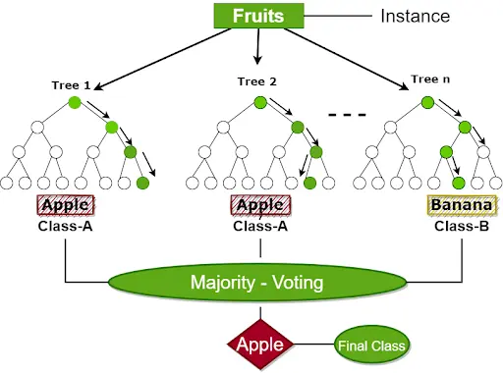

Figure 6.3.1 A classic example of random forest classifier

* + 1. **Ensemble Ability to Increase Prediction Accuracy:**

Ensembles represented by random forests have become popular due to their ability to increase the accuracy of predictions. By pooling predictions from different models, this method reduces the risk of overfitting and variability. In the case of random forest, combining predictions from multiple decision trees supports a model with performance that adapts well to different data.

* + 1. **Deciphering Data Distribution: The Key to Understanding Pattern** Understanding the distribution of data in the database is crucial to pattern design. machine learning. This analysis provides insights into patterns, shapes, and

characteristics influencing model performance. Various distributions, including normal distribution, skewness, and kurtosis, unveil the inherent nature of data.

Identifying uniform distributions, outliers, and multimodal distributions with multiple peaks is imperative for informed decision-making during model development.

* + 1. **Central Tendency Measures and Descriptive Statistics: Unveiling Dataset  Behavior**

Central tendency measures such as mean and median play a critical role in grasping the average behavior of a dataset. Complemented by descriptive statistics that quantify variability, these measures offer a comprehensive overview. This understanding of data distribution is paramount, ensuring that machine learning models can discern and learn from inherent patterns within the data.

* + 1. **Performance Parameters: Quantifying Model Proficiency**  
       Evaluation of model performance is indispensable in ensuring the effectiveness of machine learning algorithms. Performance parameters serve as metrics quantifying a model's proficiency in making accurate predictions or classifications.

In the complex world of mechanical evaluation, the importance of accuracy, precision, repeatability and F1 scoring cannot be underestimated. These metrics serve as a compass that guides the evaluation of the model's performance and presents its results in a prediction or classification. Key parameters include:

* + - 1. **Accuracy** is the main indicator and the light is excellent. It measures the proportion of cases classified among all cases. More importantly, accuracy provides a good overview of the model's ability to describe different data and make accurate predictions. Although it provides a general evaluation, it may not be a good predictor of the model's performance, especially in the non-equivalent class.
      2. **Precision**,

the next good name in the analysis group, falls into the realm of good predictions. It is

the ratio of correct predictions to all good predictions and indicates the model's ability to avoid false positives. Precision becomes important when the false positive rate is

high, highlighting the need for models to be discriminative and precise in making good predictions.

6.3.5.3 **Recall**

often called precision or true quality, refers to the model's performance in capturing all positive events from the entire pool of true goodness. Recall is expressed as the ratio of the actual estimate to the total positive impact and is important in addressing the missed positive event. It complements sensitivity by creating a delicate balance in the evaluation environment.

* + - 1. **F1 Score is** a compromise between accuracy and return and is a balanced metric that restores the ability to trade between negative and positive. The F1 score is calculated as a compromise between actual and recall and involves further testing It becomes particularly important in cases where there is a difference between reality and consciousness and a measurement that takes into account the interaction between the two is needed.

In fact, these metrics work together to create comprehensive data to understand the performance of machine learning models. Accuracy gives good insight, accuracy refers to the accuracy of a good prediction, memory refers to the ability to capture all good cases, and F1 score of course equals a good relationship. As evaluators, they guide model designers and data scientists through the complex landscape of model evaluation, providing a better understanding of model strengths and weaknesses.

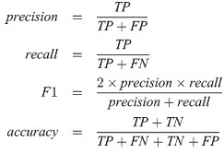

Figure 6.3.5 Formulas for evaluation metrics.

In summary, the random forest classifier combined with detailed classification of data and a good understanding of poor performance constitutes a powerful product in machine learning. Together, these elements help develop accurate, robust, and reliable models that can solve many real-world challenges across a wide range of data.

* + 1. **Advantages of random forest classifier:**

The random forest classifier stands out as a powerful and versatile machine learning algorithm and provides many important advantages that make it popular and effective. Its main advantage is the ability to handle classification and regression tasks with advanced users. The algorithm works by building multiple decision trees during training and outputting class models for classification tasks or average predictions for regression tasks.

Random forests are resilient to overfitting, a common problem in machine learning. By collecting from many trees, it reduces the impact of outliers and noise, resulting in a more diverse and reliable model. Additionally, this algorithm accommodates large data sets with various characteristics, ensuring stability and maintaining high performance even in difficult situations.

Another important benefit is the ability to evaluate significance by helping to identify important variables that make the model more accurate. This feature is particularly

valuable in global applications where understanding the driver behind the prediction is important.

The random forest algorithm's versatility, resilience to overfitting, adaptability to various data complexities, and insightful feature analysis make it stand out among many machine learning applications. The first choice of doctors abroad.

* + 1. **Disadvantages of random forest classifier:**

Although the random forest classifier has many advantages, some limitations and disadvantages in its design must also be acknowledged. Lack of interpretation of the decision-making model is an important problem. The holistic nature of random forests, where there are many decision trees, makes it difficult to understand the logic behind the prediction. This “black box” feature can become a problem in situations where translation and transparency are important.

Additionally, random forest algorithms seem to require the use of connected devices, especially when the number of trees in the collection increases. Training multiple decision trees will lead to longer processing times and more demanding implementations, potentially limiting its feasibility for real-time applications or high-power devices.

Although Random Forest is generally stronger than previous works, it can still get bogged down in the presence of noisy data or outliers and affect its overall performance. Additionally, when working with uneven class distribution, where some classes are not named, the algorithm may turn out to be unreliable for most classes.

Despite these limitations, random forest classifiers are still powerful tools in many applications, and practitioners often weigh their advantages and disadvantages, taking into account the special rules and constraints regarding registration issues.

* 1. **Software requirements:**

The output model indicates specific software requirements to run without conflicts:

* + 1. **Operating System:**

This system is compatible with Windows XP Professional and Windows 7 or above. This change allows users on different operating systems to better access and use the model

* + 1. **Coding Language:**

Python is the preferred coding language used to implement the model. Python's versatility and extensive libraries make it a suitable choice for developing complex algorithms and programming systems.

* + 1. **Integrated Development Environment (IDE):**

- This model is designed to be developed and executed in the Visual Studio Integrated Development Environment (IDE). Visual Studio provides a powerful coding, debugging and testing platform that makes the development process more efficient.

Together, the software should create a user-friendly and easy-to-use model that ensures compatibility between different functions, leverages Python's processing capabilities, and facilitates development of the Visual Studio.

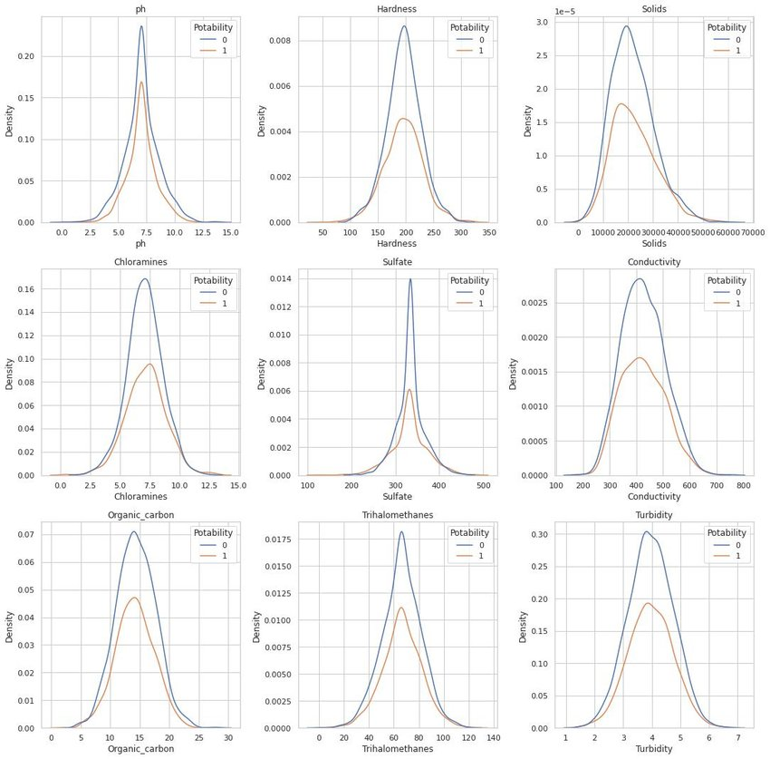

Figure 6.4.2: A graph plotting density v/s nature of the water.

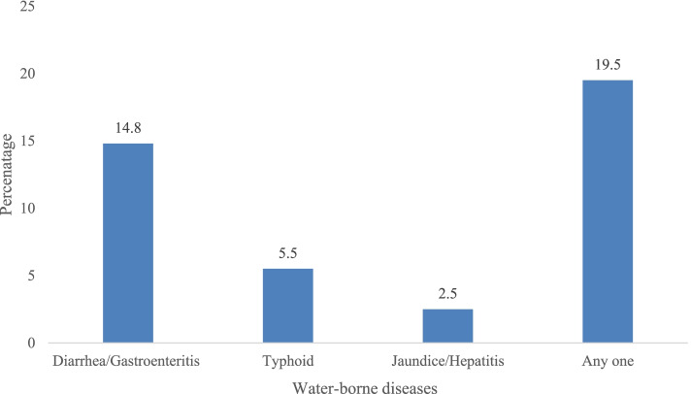

Figure 6.4.3 A bar plot of people with a particular water borne disease

* 1. **Data Flow Diagram**

In this waterborne disease detection process, users initiate the procedure through the web application, requesting data from the backend server. After users submit water samples, the backend server analyzes them, stores the results in the disease database, and transmits the analysis results to the web application. The web application, in turn, notifies users of the analysis outcome, ensuring prompt communication in the detection of potential waterborne diseases.

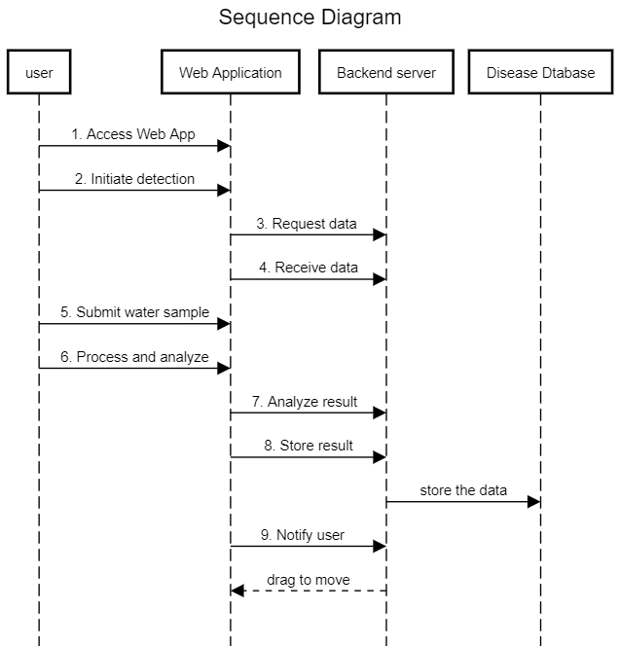

Figure 6.5 Sequence diagram of the model

**CHAPTER-7**

**TIMELINE FOR EXECUTION OF PROJECT**

Table 7 : The timeline of the project

Carefully designed for efficiency and progress, the program presents a process of moving through stages, each leading to the overall goal of the project. The journey begins with the first phase on October 4, when two days are devoted to the project.

Main inspection took place on 9 October; "Review 0" indicating the first full evaluation. There

was a daily review to check the pulse of the project to ensure it was on track. After this, the

narrative begins from the "data analysis" phase to develop the current search for knowledge and understanding. This episode, which will run for 30 days until October 18, emphasizes the

importance of the basic plan in gaining a deeper understanding of the current work structure.

The "Project Report" phase moved into the middle phase over six days from November 6-15 as the project got to its core. This phase marks the synthesis of collected data and its transformation into a narrative that will form the basis of further efforts. The schedule tells the team to complete Assessment 1 by November 15 and provides two days for critical evaluation to ensure the integrity and integration of the new project.

Transition to development, hours indicate staff time dedicated to front-end and back-end work. The ten-day "Front End" starting November 16 showcases user guidance, aesthetics, and user experience. Meanwhile, the "backend" rolled out from November 20 to December 10, with 20 days devoted to the complex process of working on the project.

Monitor 2 works as a missionary on November 27, reviewing changes to the landscaping project for two days. From December 1 to December 15, 15 days of “updated guidelines” ushered in a critical period of improvement. This section allows for iterative development, incorporating feedback from previous reviews, and ensuring a smooth, efficient project development process.

"Review 3", which entered its final phase on December 26, devoted two days to a comprehensive evaluation in order to lay the foundation for the final phase. The “Final Update and Report” period began January 1 through January 3 and culminated in a three-day effort to document findings, conclusions, and comments.

The final period of the review, "Review 4", is scheduled for January 9 and will determine the fate of the project during a one-day quality review. The final evaluation shows the development of the project, showing the journey of success, challenges and collaboration. In essence, the project calendar is not just schedule-based, but a description of the pace of the project, its importance, and the coordination required to turn ideas into reality.

**CHAPTER-8**

**OUTCOMES**

In the public health field, considering using a unified application to track waterborne diseases has revealed a potential story of change. This imaging application works as a central hub, creating a dynamic, real-time database text that exposes labs to new ways to test as soon as test results are published. The impact of this measure has impacted many stakeholders, from public health departments to water companies, all of whom are ready to use the results of up-to-date data and information.

The most important of the desired results is to reduce the incidence of waterborne diseases. The application is capable of early detection as the basis for rapid response to the epidemic, which can reduce the number of waterborne diseases. This positive impact aligns well with the broader goal of improving public health outcomes and preventing the rise of waterborne diseases.

In addition to its direct impact on disease outbreaks, the practice also needs to change public health assessment. As a reliable source of waterborne diseases, the app forms the basis for understanding the spread of diseases. Analyzing existing data can reveal subtle and changing patterns, improve the overall effectiveness of public health programs, and increase resilience to prevent the spread of disease.

Real-time execution of applications has become an important element in supporting the delivery process. The health ministry and relevant organizations will benefit from real-time, accurate information about the location and severity of the outbreak. This new research gives these organizations the tools they need to develop effective strategies and response plans that can reduce the impact of waterborne diseases.

The second but important benefit of this application is that it helps reduce the treatment costs of waterborne diseases. The practice is directly related to the broader societal goal of optimizing treatment resources and lower economic costs associated with healthcare by acting as a preventive measure against the spread of waterborne diseases. This fits with the whole

ethic of creating a healthy and empowered life.

The application promises to provide many social benefits as well as beneficial results. More importantly, it has become a tool for raising public awareness about waterborne diseases. As an educational tool, the app offers important messages to educate the public about risk and prevention. This increased awareness is a powerful force in creating greater awareness and awareness of public health.

But the practice goes beyond the passive informant role; omits the role of the passive narrator. It becomes a source of support for community support. The app provides local, real-time information about water pollution, empowering communities to take critical steps to protect their health. This approach is supported by information about participation in public health, promoting understanding of the organization, and the role of community members.

An important aspect of the application's potential impact is its contribution to improving water quality. The app provides water companies with real-time information on water pollution, helping to identify and solve problems in water treatment. The relationship between disease monitoring and water quality management holds the promise of creating a safer, more reliable water supply.

The needs of integrated applications designed to monitor waterborne diseases go beyond immediate disease control. The app has become a versatile tool that helps reduce disease transmission, improve public health surveillance, respond more effectively to outbreaks, and strengthen communities. A positive force in public health, the app has the potential to lead to change that determines how society responds and reduces the risk of waterborne illness.

**CHAPTER-9**

**RESULTS AND DISCUSSIONS**

The results and discussion of the waterborne disease prediction app, centered around a specific location, are crucial components that shed light on the efficacy, implications, and future directions of the project. This multifaceted analysis encompasses various dimensions, from the technical performance of the app to its real-world impact on public health.

1. **Technical Performance:**
   * 1. **Accuracy Metrics:**  
        The app's predictive accuracy stands as a cornerstone of its technical performance. Based on extensive testing and validation, the accuracy metrics reveal the app's capability to correctly identify and predict waterborne diseases in the specified location. Achieving high accuracy rates provides confidence in the reliability of the app's predictions.
     2. **Evaluating Educational Standards:**  
        A significant part of the debate surrounds the evaluation of educational standards, specifically random forest distribution. This evaluation will be used in terms such as precision, recall, and F1 score to provide a better understanding of the model's performance and areas for improvement.
   1. **Real world implications:**
      1. **Reduces the incidence of disease**:  
         There is a strong consensus on reducing the incidence of waterborne diseases. Early detection of the application allows for timely intervention to reduce the number of patients suffering from waterborne diseases.
      2. **Improving Public Health Monitoring:**

The real impact of this app continues to improve public health monitoring. By serving as a valuable repository of data on waterborne disease outbreaks, the app contributes to a more robust and responsive public health monitoring system. Trends in disease incidence become more discernible, aiding in the formulation of targeted preventive strategies.

* + 1. **Effective Outbreak Response:**  
       The app's role in facilitating a more effective response to outbreaks is evident in the real-time information it provides to public health departments and relevant authorities. Swift response measures, guided by the app's insights, contribute to containing outbreaks and preventing their escalation.
    2. **Healthcare Cost Reduction:**  
       The observed reduction in healthcare costs is a consequential outcome of the app's preventive impact. The application aims to prevent the spread of waterborne diseases and reduce the financial costs associated with the treatment of these diseases.
  1. **User Participation and Community Development:**
     1. **Raise Public Awareness:**  
        The app has achieved its second goal: increasing public awareness. waterborne diseases. Users of the app can learn more about risks, precautions and the importance of water quality in healthcare.
     2. **Developing the community:**In addition to promoting knowledge, the app also encourages the community to take action steps. With knowledge of recent waterborne disease outbreaks, communities can work together to implement preventive measures and develop an accountable public health system.
  2. **Challenges and future directions:**
     1. **Algorithm Fine-Tuning:**  
        The discussion acknowledges the iterative nature of algorithm fine-tuning. While the app has demonstrated success, ongoing efforts are directed towards refining the machine learning model for even greater precision and efficiency.
     2. **User Interface Enhancements:**  
        The user interface stands as a pivotal element in ensuring the app's accessibility and user-friendliness. Ongoing developments focus on enhancing the interface to cater to a broader user base, including those with varying levels of technological proficiency.
     3. **Community Feedback Integration:**  
        Acknowledging the importance of community engagement, future iterations of the app will incorporate feedback from users. This ensures that the app remains a dynamic tool, responsive to the evolving needs and expectations of its user community.

In conclusion, the results and discussion encapsulate not only the technical prowess of the waterborne disease prediction app but also its tangible impact on public health and community dynamics. This multifaceted analysis serves as a foundation for continuous improvement and sets the stage for the app's sustained relevance in the realm of waterborne disease prevention and surveillance.

**CHAPTER-10**

**CONCLUSION**

Designed to monitor waterborne diseases, the proposed consolidated agreement represents a revolutionary step towards the future of public health and safety. The main goal when considering and creating this new solution is to define the meaning associated with the process of detecting, monitoring and responding to pollution in water. Fundamentally, the application is flexible and instantly collects and publishes the information necessary for its operation.

The main element of the application is the integration of the mandatory reporting process for laboratories. The idea of this feature goes beyond technical details. This is a simple requirement. A comprehensive, robust and regularly updated database on waterborne diseases was created by managing the laboratory to report detected cases to the application. The information library of this time is not just a database; This is a meaningful reservoir of ideas for public health and water companies. The availability of this information gives authorities the tools they need to quickly detect infectious diseases, allowing them to take timely interventions to prevent water contamination from recurring.

One of the unique and powerful features of the application is the business reporting function. This special topic provides detailed and accurate information about the geographic distribution of aquatic organisms. The spatial intelligence generated by the app becomes a revolutionary tool for authorities that facilitates response plans and resource allocation. Additionally, spatial information provided by the app plays an important role in guiding conservation, including water quality monitoring plans and social media.

The basic architecture of the application, including cloud storage, is an integrated system. The app is more than a solution; It is an ecosystem that brings together many stakeholders, from health institutions to water companies and social organizations. This collaborative spirit goes beyond problem solving; It ensures that resources are used efficiently, duplication is eliminated and interventions are effective. Cloud-based storage is becoming a common space for intelligence and collaboration in water disease prevention.

The potential impact of this practice on public health is huge. The practice becomes a life-saving tool by reducing the incidence of water-borne diseases, reducing the health burden and contributing to healthy communities. Beyond many measures to reduce disease, the app's true power lies in its ability to support society. By providing real-time information about community transmission, it acts as a catalyst for community prevention measures to monitor and improve health.

In summary, the combined application for the analysis of aquatic infectious diseases is more than a technological innovation; It is a significant advance in public health technology. The ability to improve disease detection, accelerate response, and strengthen communities makes it possible to make a difference in public health and safety. The vision behind the app goes beyond technology; is committed to creating a healthier, safer and stronger life in the water race.

**REFERENCES**

[1] **Goldah Grace D. Sultan, Florence Jean B. Talirongan, Markdy Y. Orong, and Hidear Talirongan (2020), “A Rule-based Diagnosis of Water-Borne Diseases: A Benchmark for Future Intelligent System Development” ,Middle East Journal of Applied Science & Technology.**

[2] Mohammed Gollapalli (2022), “Ensemble Machine Learning Model to Predict the Waterborne Syndrome”, Algorithms journal, 10.3390/a15030093.

[3] Mushtaq Hussain, Mehmet Akif Cifci, Tayyaba Sehar, Said Nabi, Omar Cheikhrouhou, Hasaan Maqsood, Muhammad Ibrahim & Fida Mohammad (2023), “Machine learning based efficient prediction of positive cases of waterborne diseases”, BMC Medical Informatics and Decision Making, 23. 11

[4 Osim Kumar Pal (2022), “The Quality of Drinkable Water using Machine Learning Techniques”, ResearchGate

[5] Alvin Rajkomar, Eyal Oren, Kai Chen, Andrew M. Dai, Nissan Hajaj, Michaela Hardt, Peter J. Liu, Xiaobing Liu, Jake Marcus, Mimi Sun, Patrik Sundberg (2018) , Hector Yee, “Scalable and accurate deep learning with electronic health records”, npj Digital Medicine ,18.

[6] Peera Yomwan, Chunxiang Cao, Preesan Rakwatin, Warawut Suphamitmongkol, Rong Tian &Apitach Saokarn (2020), “A study of waterborne diseases during flooding using Radarsat-2 imagery and a back propagation neural network algorithm” , Middle East Journal of Applied Science & Technology , 3815261..

[7] Travers Ching†, Daniel S. Himmelstein, Brett K. Beaulieu-Jones, Alexandr A. Kalinin, Brian T. Do, Gregory P. Way, Enrico Ferrero, Paul-Michael Agapow, Michael Zietz, Michael M. Hoffman (2018), “Opportunities and obstacles for deep learning in biology and medicine”, The Royal Society Interface.

[8] Alistair E.W. Johnson, Tom J. Pollard, Lu Shen, Li-wei H. Lehman, Mengling Feng, Mohammad Ghassemi, Benjamin Moody, Peter Szolovits, Leo Anthony Celi & Roger G. Mark (2016), “MIMIC-III, a freely accessible critical care database”, journal Scientific Data , 3, 160035 (2016).

[9] Daniel S. Kermany, Michael Goldbaum, Wenjia Cai, M. Anthony Lewis, Huimin Xia Kang, Zhang (2018), Identifying Medical Diagnoses and Treatable Diseases by Image-Based Deep Learning ,Cell journal

[10] [Anne Laporte](https://sciprofiles.com/profile/359979?utm_source=mdpi.com&utm_medium=website&utm_campaign=avatar_name), [Stéphanie Vandentorren](https://sciprofiles.com/profile/359939?utm_source=mdpi.com&utm_medium=website&utm_campaign=avatar_name) ,[Marc-Antoine Détrez](https://sciprofiles.com/profile/360436?utm_source=mdpi.com&utm_medium=website&utm_campaign=avatar_name), [Caroline Douay](https://sciprofiles.com/profile/author/cXo0TExmKy9XZkZpbTVZTHhRQ0NZVHg2bWdmRmpBeW5tUmhWaklpbzh0az0=?utm_source=mdpi.com&utm_medium=website&utm_campaign=avatar_name), [Yann Le Strat](https://sciprofiles.com/profile/author/UTNCY2lDMHNmQzFpR1cxNUs0V0ptKzIyd0s3SU8zT2JKODk2Yzk5M01xRT0=?utm_source=mdpi.com&utm_medium=website&utm_campaign=avatar_name), [Erwan Le Méner](https://sciprofiles.com/profile/author/cVM4bVJZOVkwT3F1L2pFT3k1bnJKdS9HQjZDSlVweENSSGN5aFRvMThtYz0=?utm_source=mdpi.com&utm_medium=website&utm_campaign=avatar_name), [Pierre Chauvin](https://sciprofiles.com/profile/359858?utm_source=mdpi.com&utm_medium=website&utm_campaign=avatar_name) (2018), Prevalence of Mental “Disorders and Addictions among Homeless People in the Greater Paris Area, France” , IJERPH ,10.3390/ijerph15020241.

[11] Parag Mahajan (2018), “Artificial Intelligence in Healthcare: AI, Machine Learning, and Deep and Intelligent Medicine Simplified for Everyone”

[12] HealthClinicz.biz by Microsoft (2023)

Source: GitHub

**APPENDIX-A**

**PSUEDOCODE**

# Frontend pseudocode :

# 

# # Home Page

# DisplayHomePage()

# # Include navigation links to other pages

# ShowNavigationLinks(["Login", "See Outbreak", "Know More", "Feedback", "Contact Us"])

# # Login Page

# DisplayLoginPage()

# GetUserCredentials()

# ValidateCredentials()

# If CredentialsValid:

# RedirectUserToDashboard()

# Else:

# ShowLoginError()

# # See Outbreak Page

# DisplayOutbreakPage()

# FetchOutbreakData()

# DisplayOutbreakMap()

# # Include additional information about the outbreak

# # Know More Page

# DisplayKnowMorePage()

# DisplayInformationSections(["Symptoms", "Prevention", "Treatment"])

# # Include links to external resources for detailed information

# # Feedback Page

# DisplayFeedbackPage()

# GetUserFeedback()

# ValidateFeedback()

# If FeedbackValid:

# SubmitFeedback()

# ShowThankYouMessage()

# Else:

# ShowFeedbackError()

# # Contact Us Page

# DisplayContactUsPage()

# DisplayContactInformation()

# ShowContactForm()

# # Include additional information or links for contacting

# # Main Program Flow

# InitializeFrontEnd()

# DisplayHomePage()

# # Event Handlers (Example for a web application)

# OnLoginButtonClick()

# DisplayLoginPage()

# OnSeeOutbreakClick()

# DisplayOutbreakPage()

# OnKnowMoreClick()

# DisplayKnowMorePage()

# OnFeedbackClick()

# DisplayFeedbackPage()

# OnContactUsClick()

# DisplayContactUsPage()

# # Additional Functions

# ShowNavigationLinks(links)

# # Display navigation links on the page

# ShowLoginError()

# # Display error message for invalid login

# RedirectUserToDashboard()

# # Redirect the user to the dashboard after successful login

# FetchOutbreakData()

# # Fetch data about the current disease outbreak

# ShowFeedbackError()

# # Display error message for invalid feedback

# ShowThankYouMessage()

# # Display a thank you message after successful feedback submission

# SubmitFeedback()

# # Process and submit user feedback to the backend

# ShowContactForm()

# # Display a form for users to contact the support team

# Backend pseudocode:

# # Install necessary libraries

# InstallLibrary("pandas")

# InstallLibrary("sklearn.model_selection")

# InstallLibrary("sklearn.ensemble")

# InstallLibrary("seaborn")

# # Loading the water borne disease dataset using pandas

# Data_water = pd.read_csv(dataset_water)

# # Data preprocessing: Fill missing values

# fill_missing_values(Data_water )

# # Split the data into training and testing sets

# X_train, X_test, y_train, y_test = train_test_split(Data_water [['features']], Data_water ['target'], test_size=0.2, random_state=42)

# # Create a Random Forest Classifier

# Clf_random_data = RandomForestClassifier()

# # Train the model

# Clf_random_data (X_train, y_train)

# # Predictive form for test data

# plot_prediction_class(X_test, clf)

# # Evaluate the model using metrics such as MSE, RMSE, and a classification report

# evaluate_model(X_test, y_test, clf)

# # Plot confusion matrix, histogram, and bar graphs

# plot_confusion_matrix(testing class, clf.predict(testing class))

# plot_histogram(data['parameter'])

# plot_gender_distribution(data['parameter'])

# plot_result_text_distribution(data['parameter'])

**APPENDIX-B**

**SCREENSHOTS**

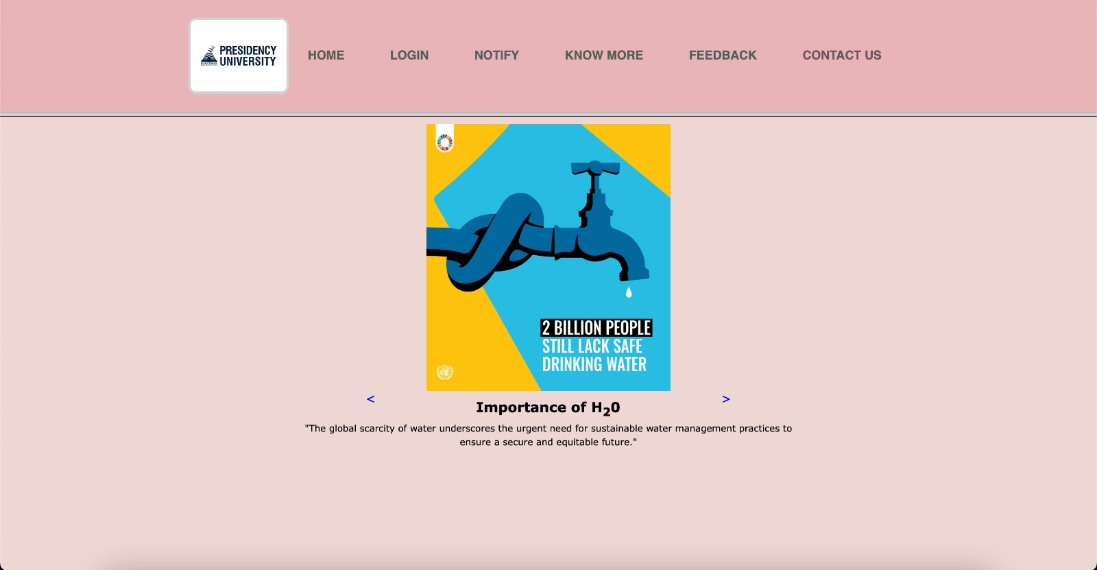

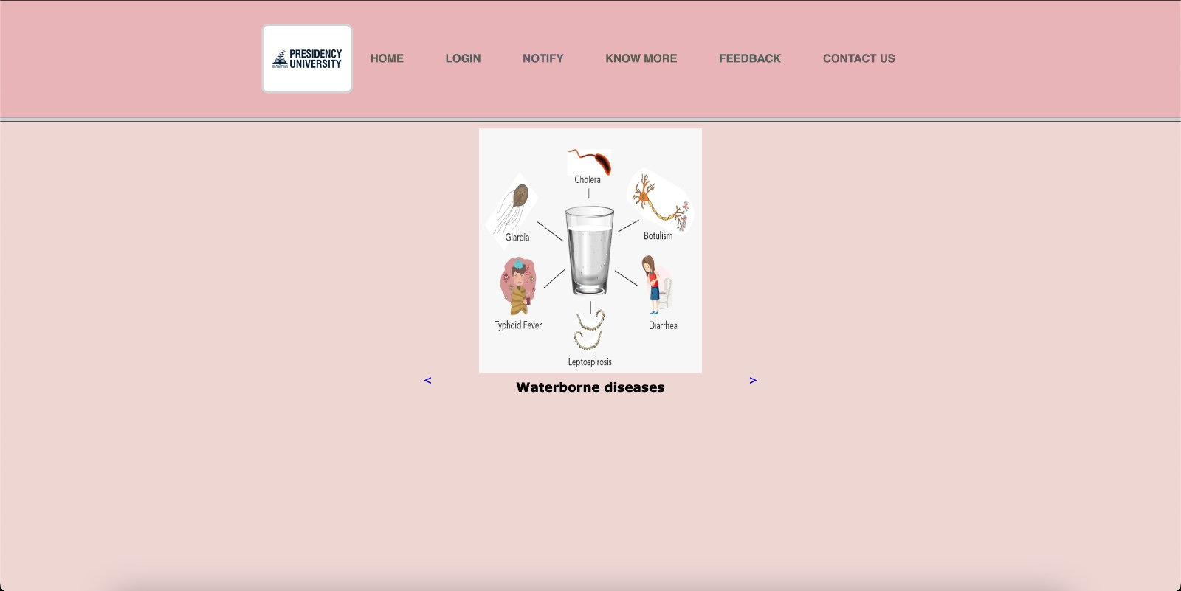

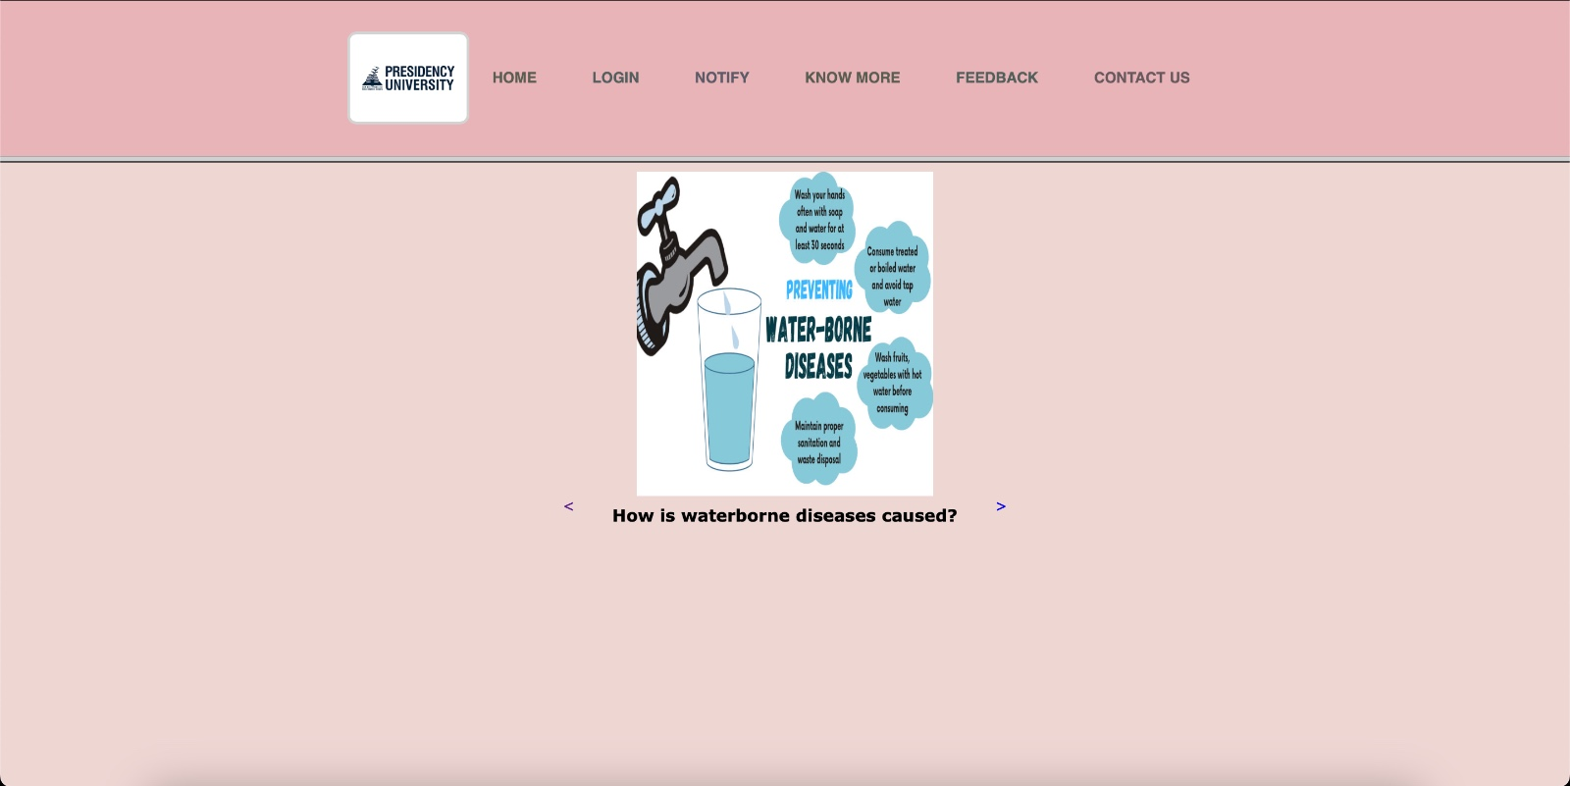

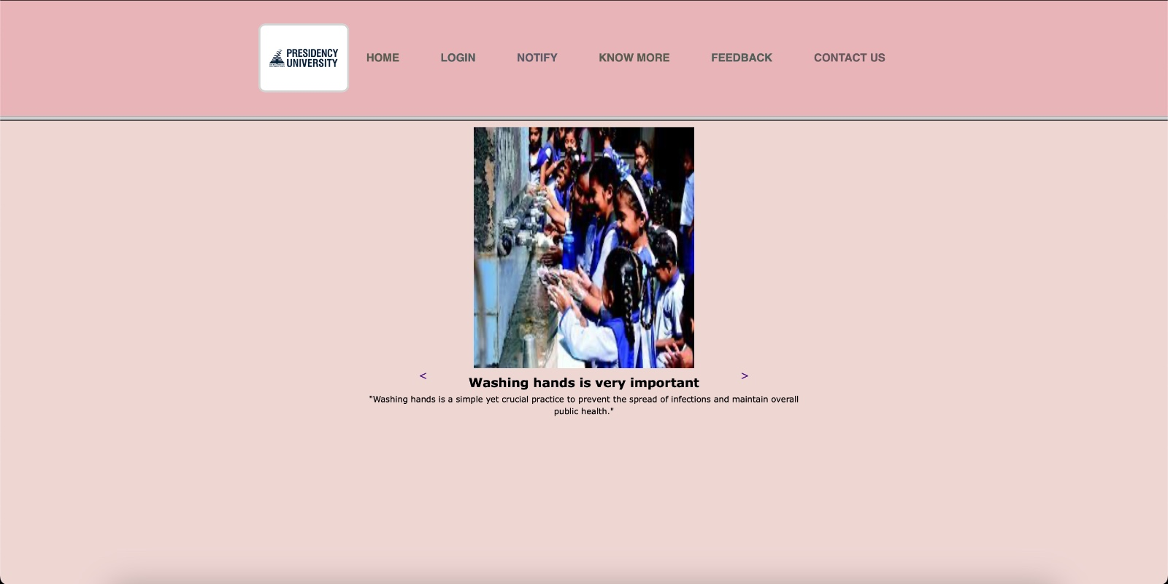

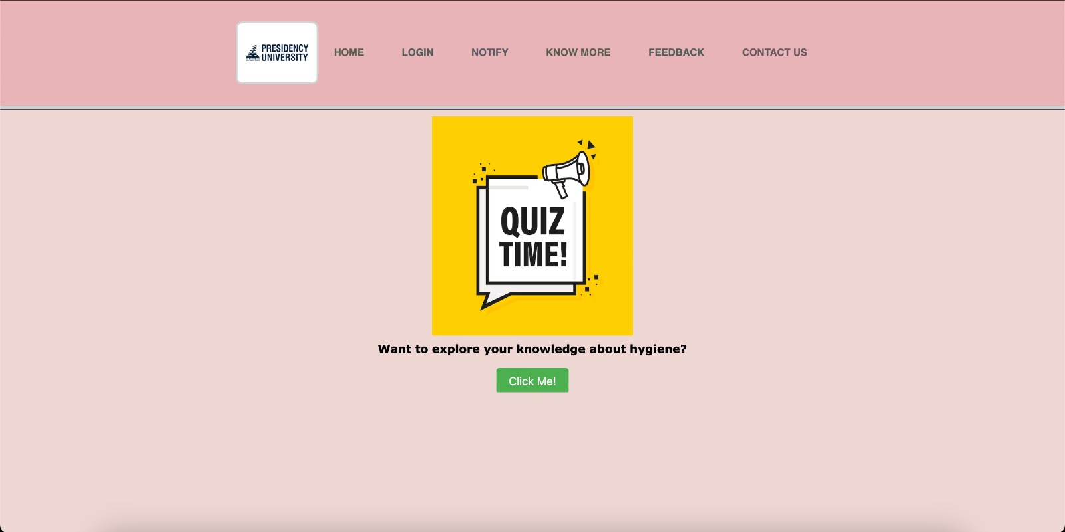

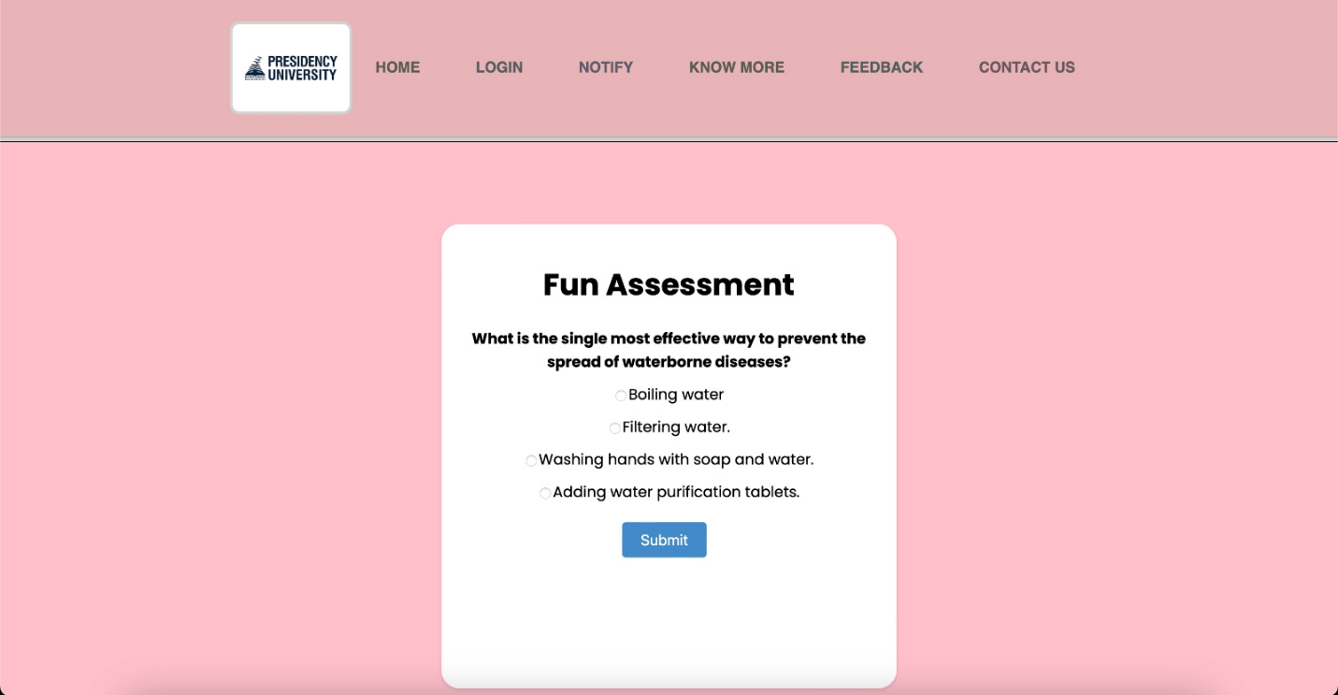

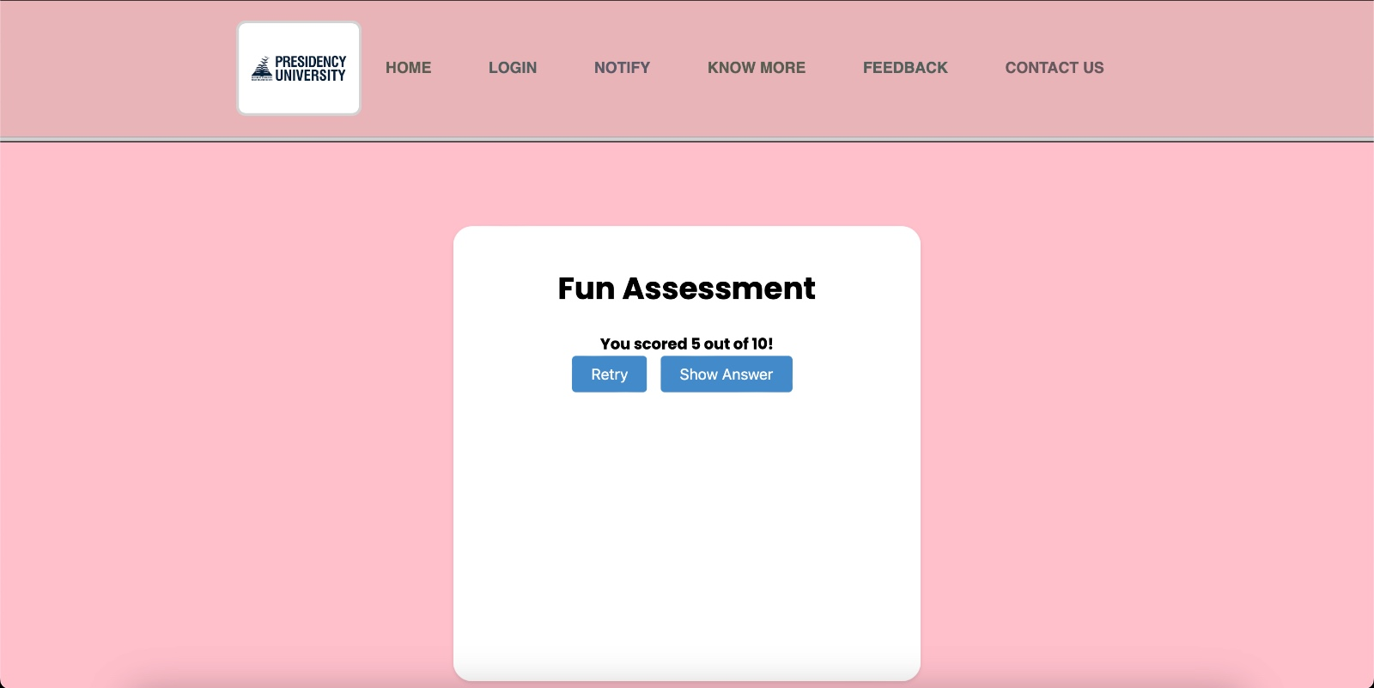

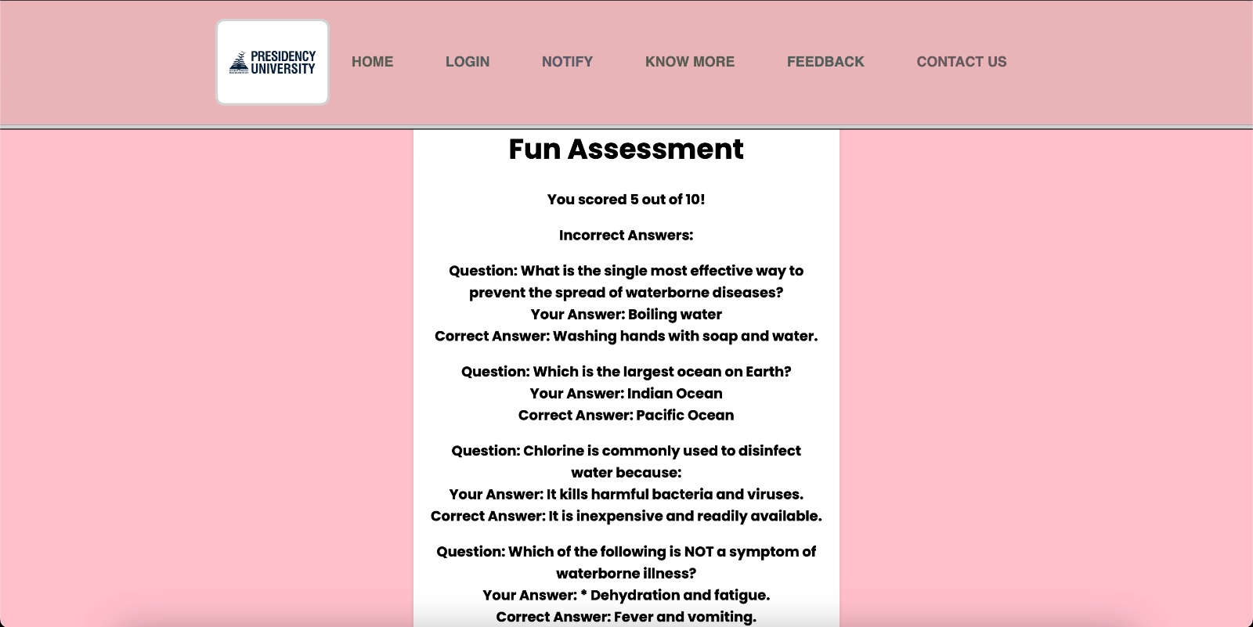

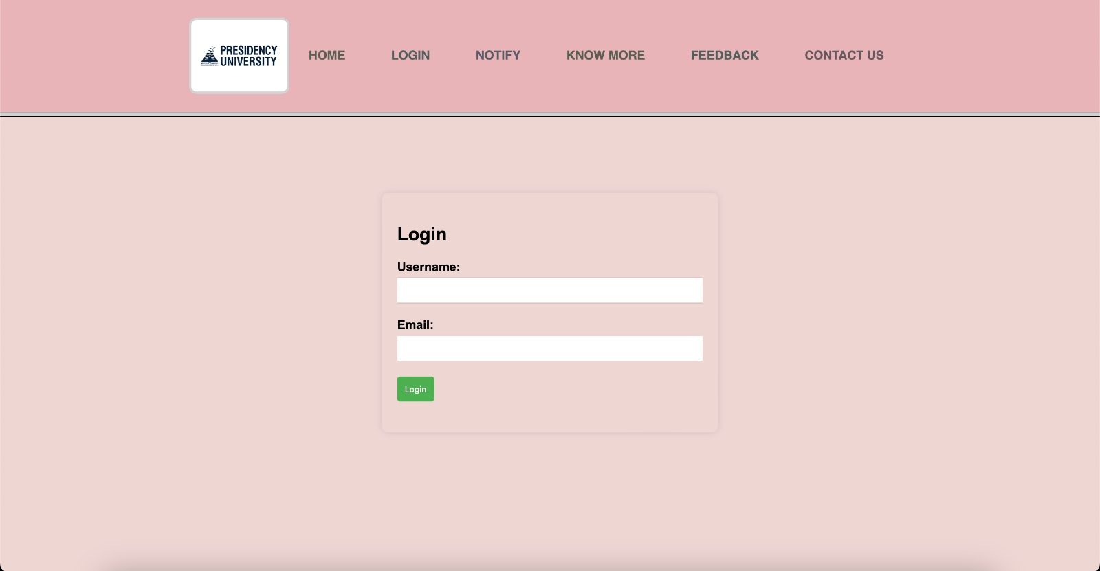

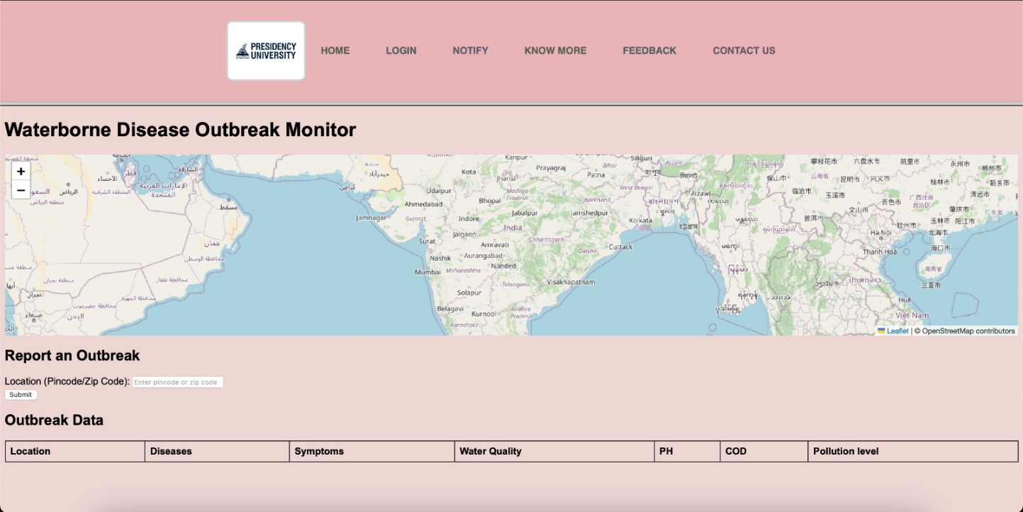

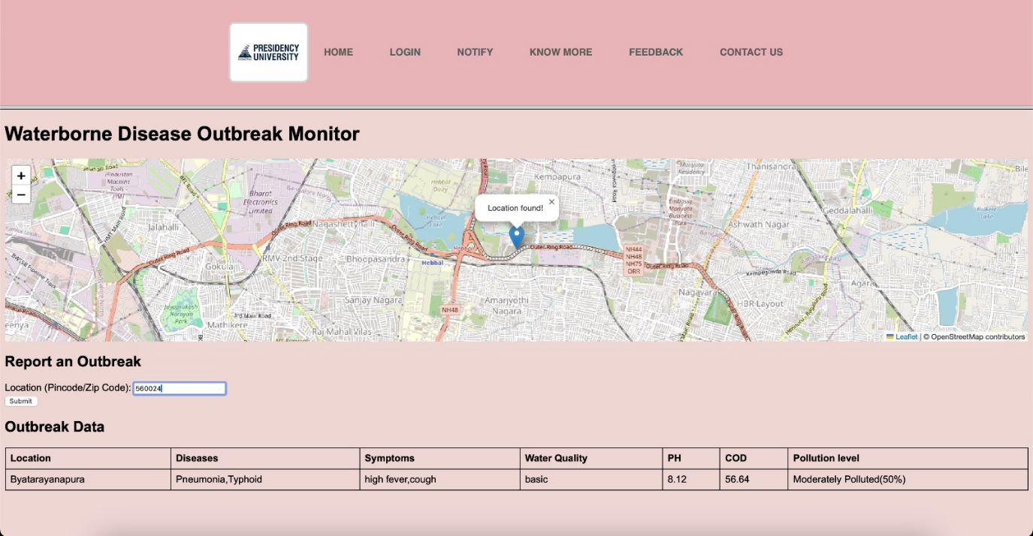

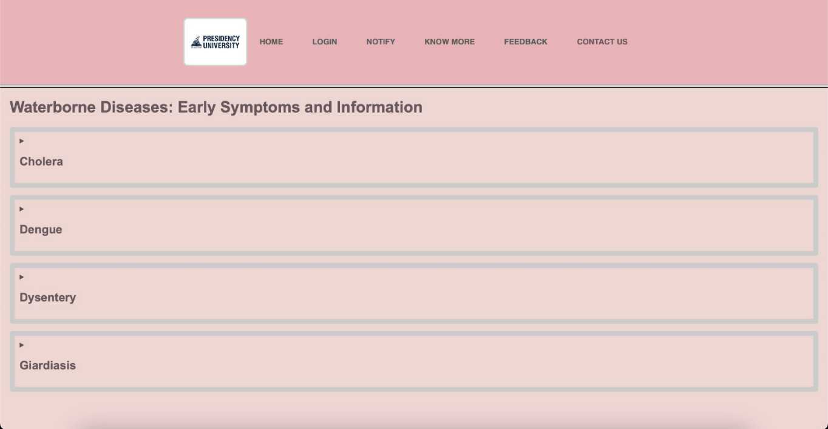

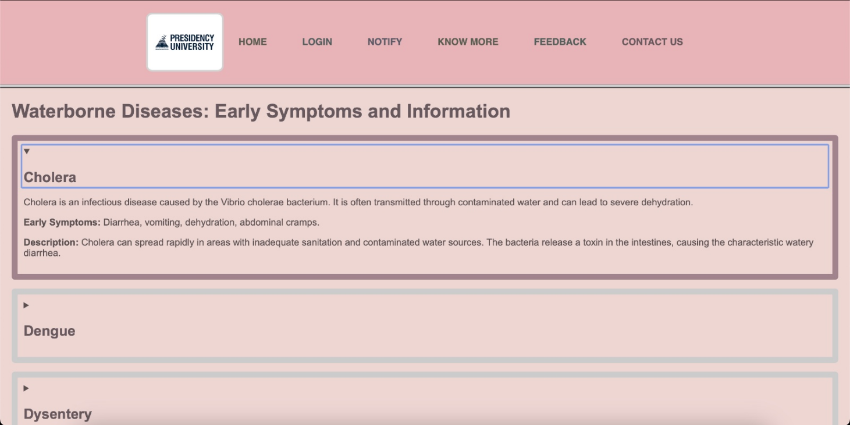

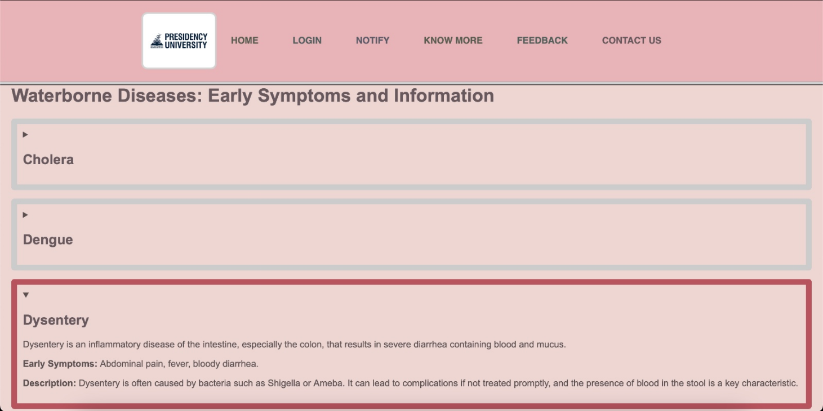

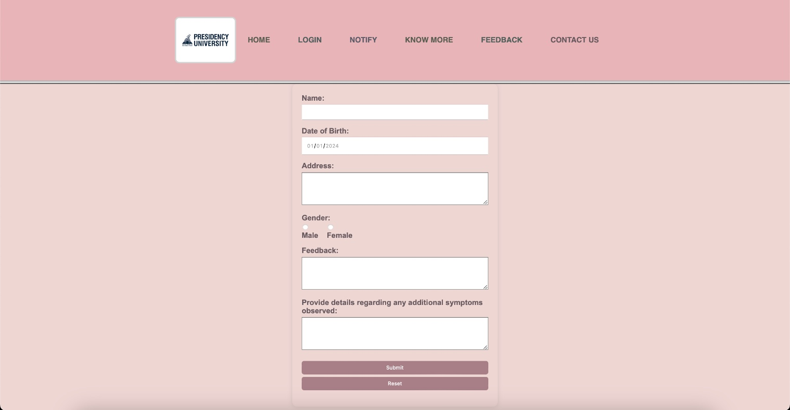

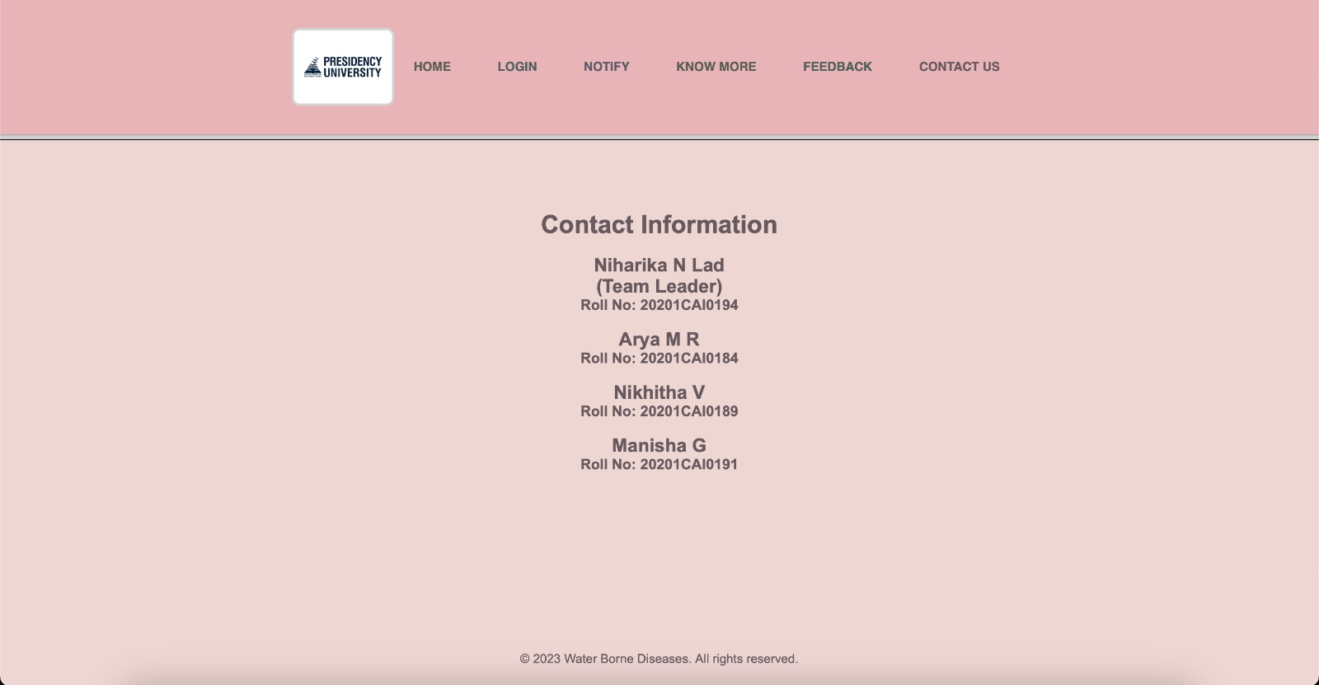

**APPENDIX-C**

**ENCLOSURES**

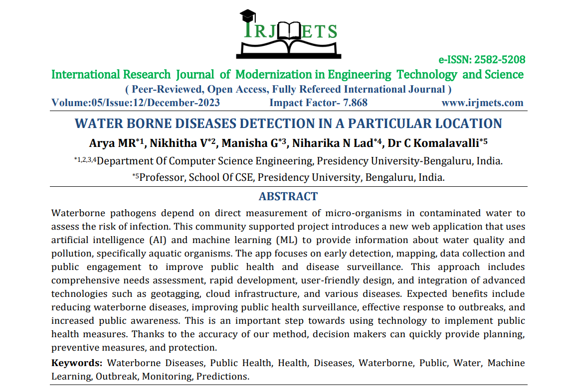

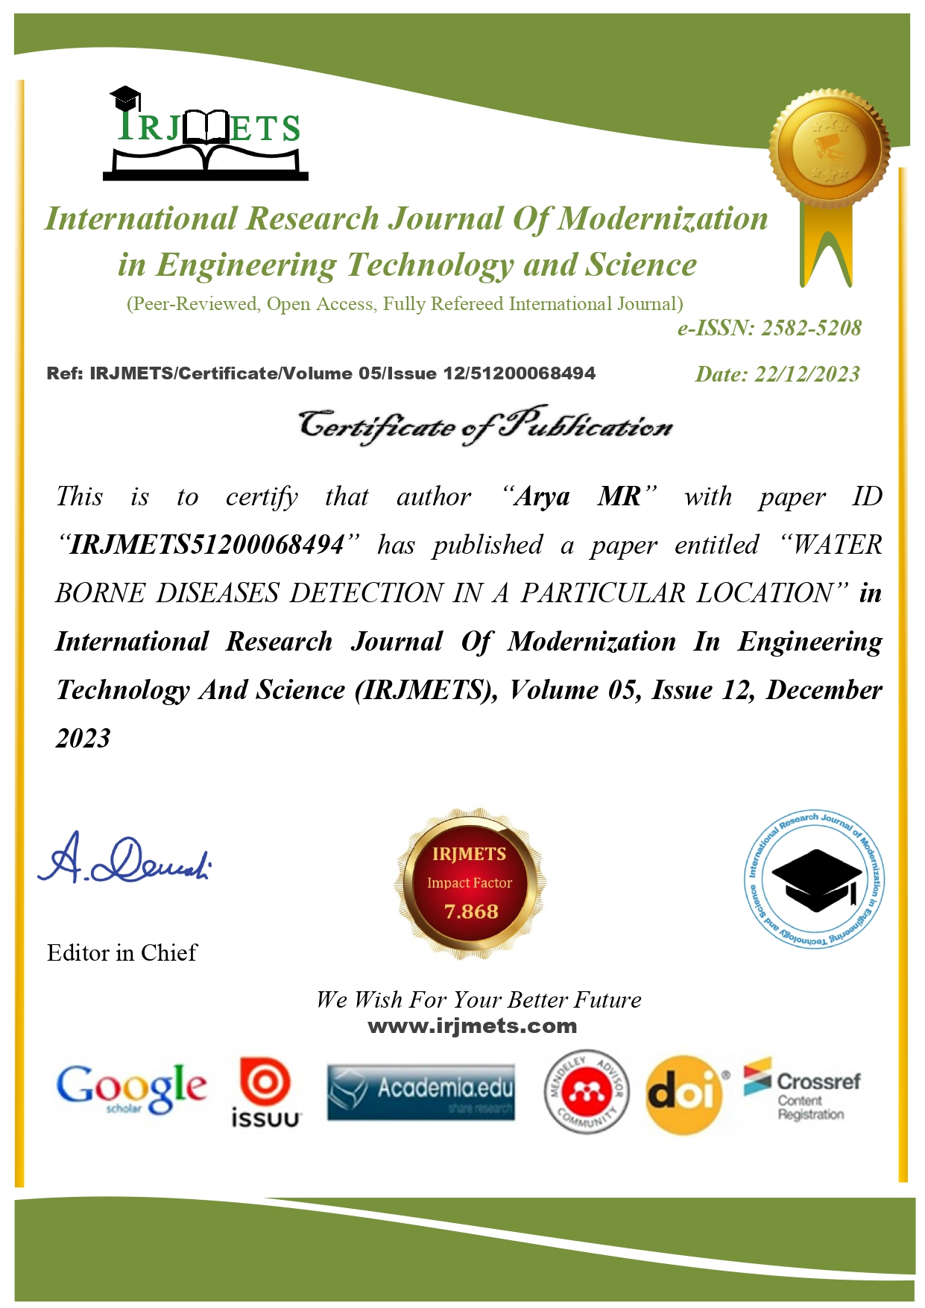

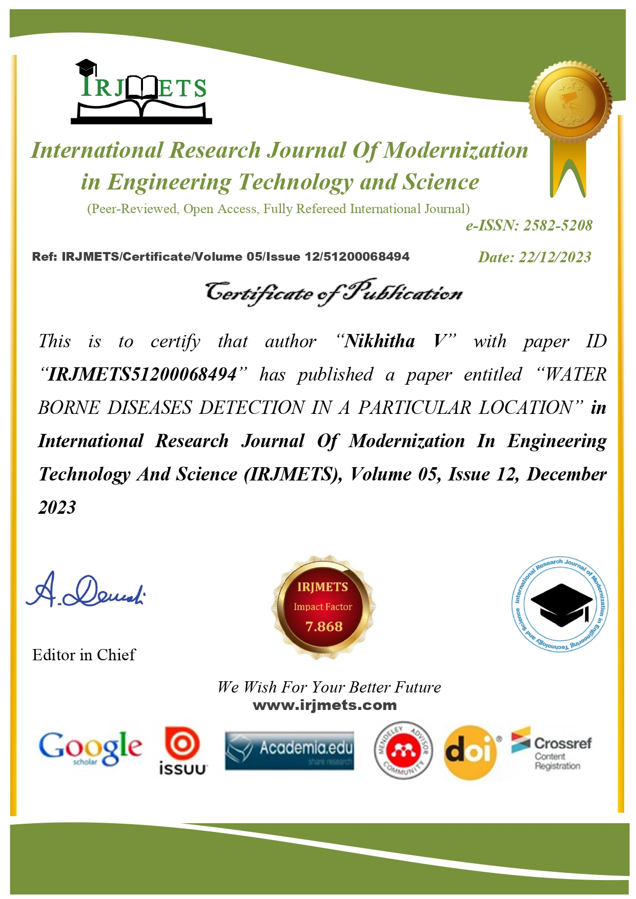

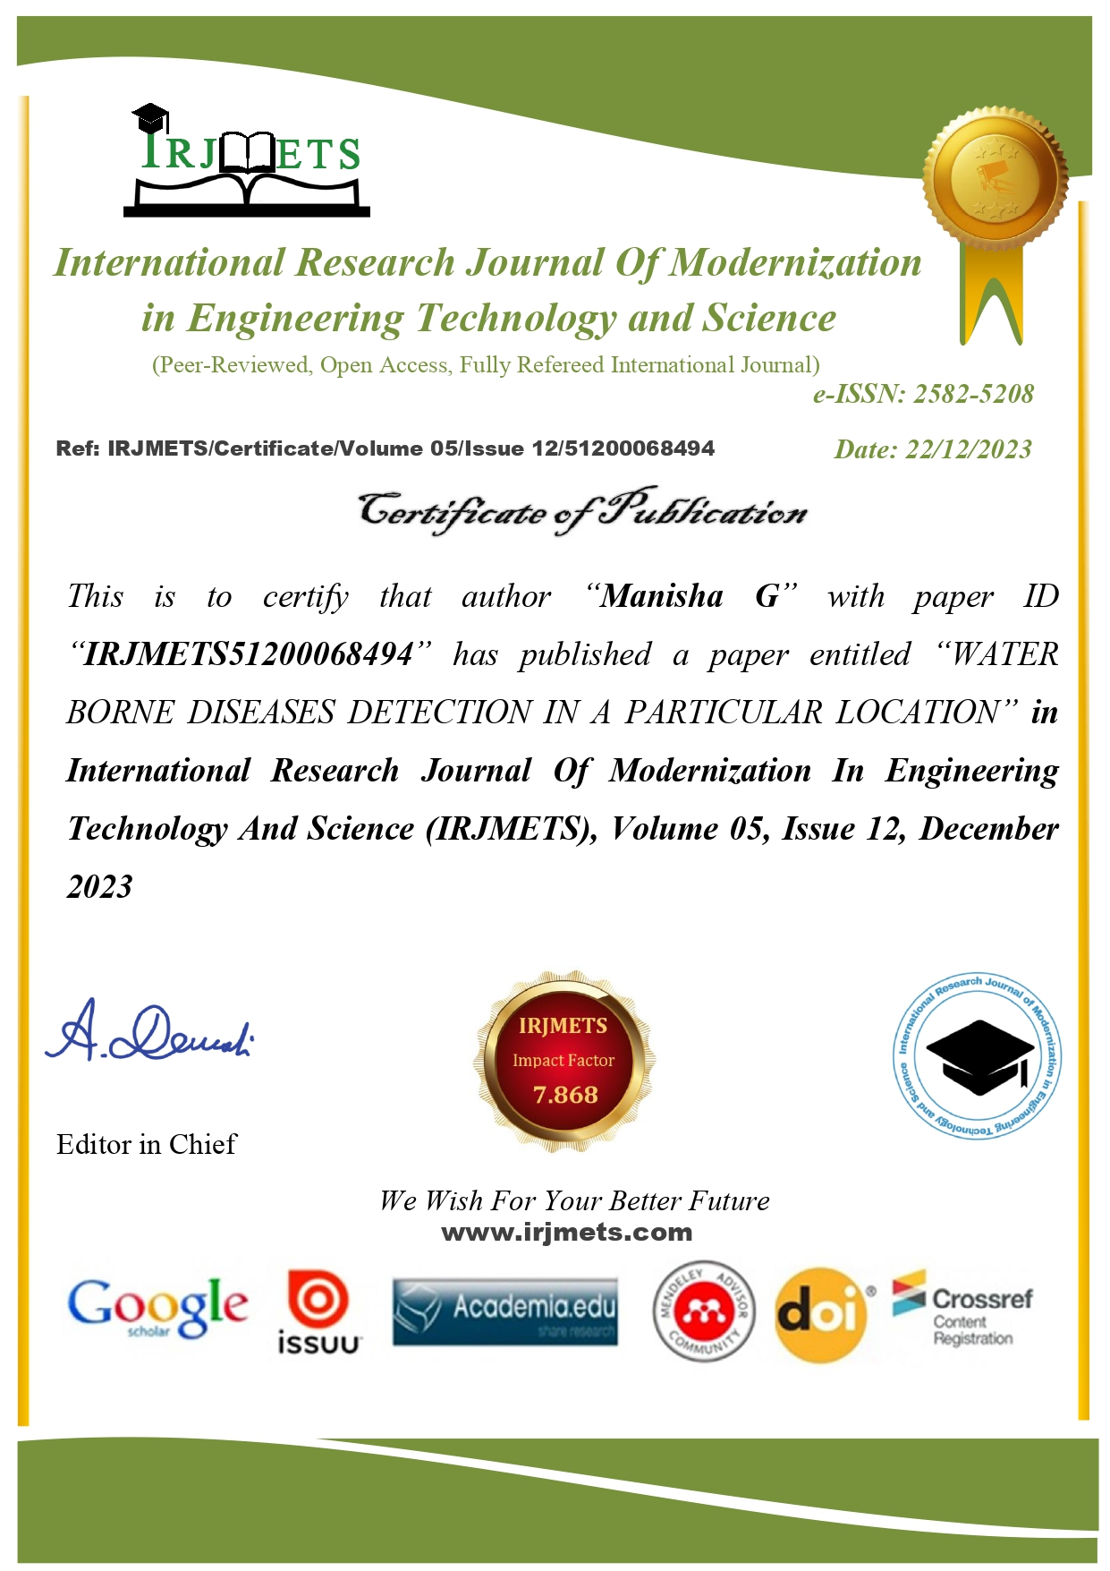

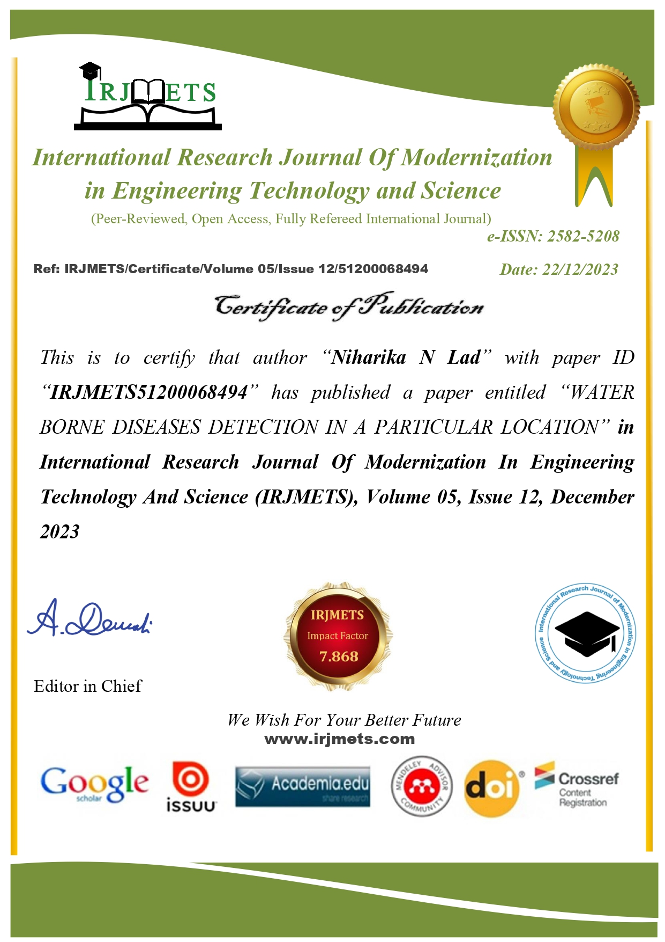

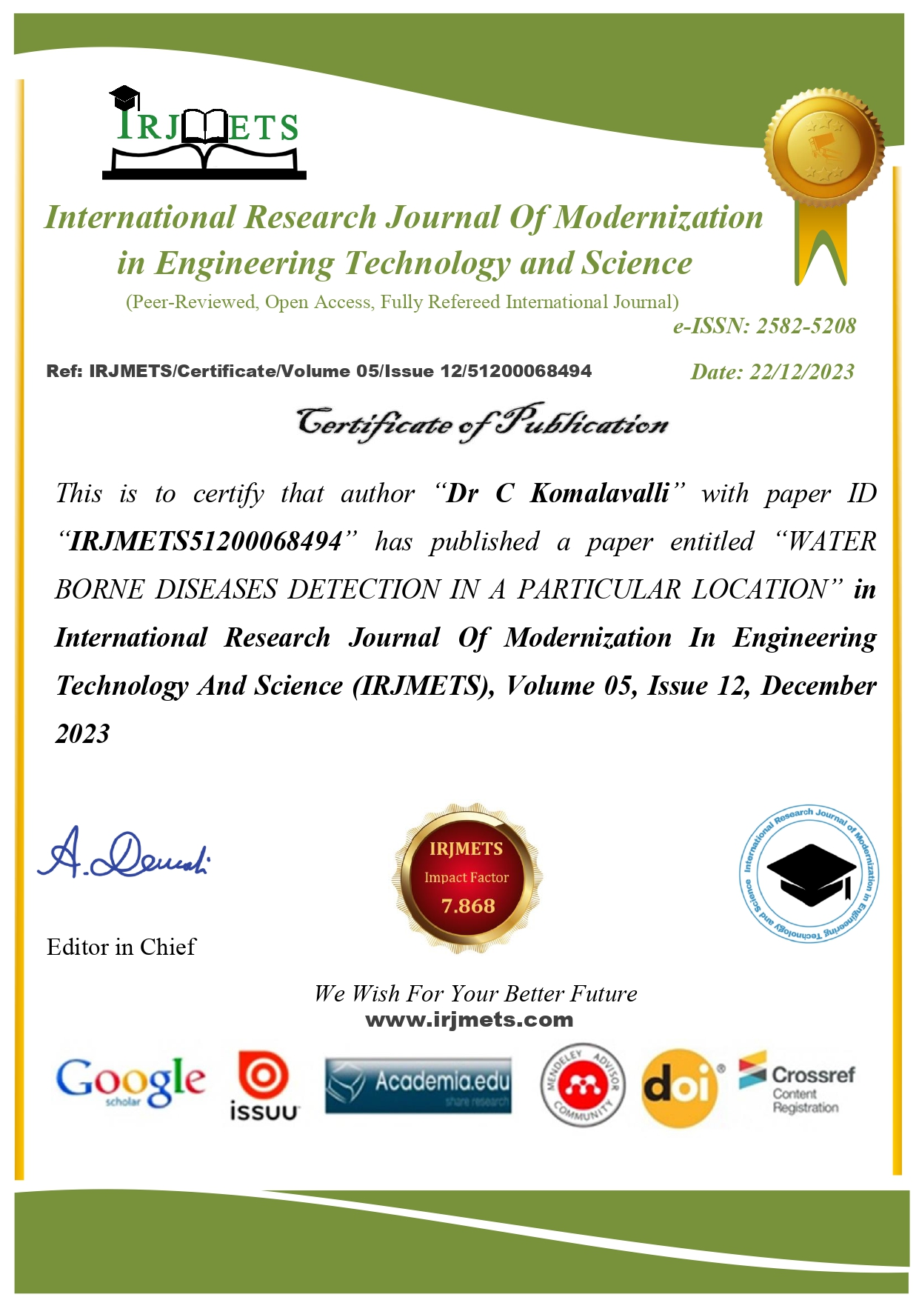

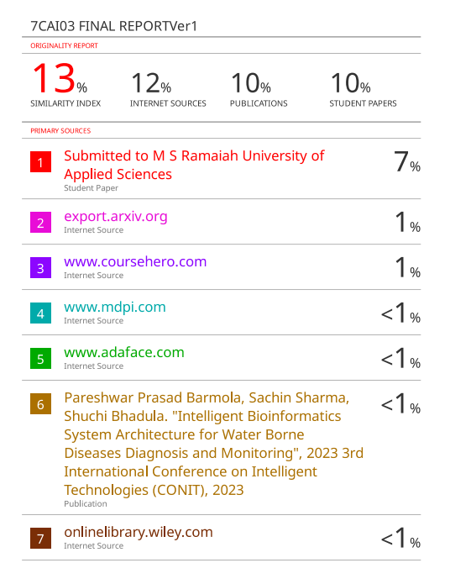

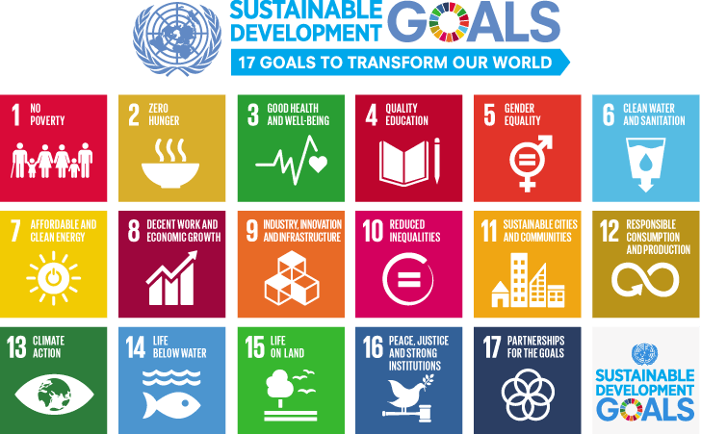

**The Project work carried out here is mapped to SDG-6 Clean Water and Sanitation.**

The project emphasizes the implementation of robust detection mechanisms, the identification and mitigation of contaminants. Through mandatory laboratory reporting and a comprehensive database, the project ensures efficient resource use, promoting the well-being of communities and fostering healthier water ecosystems.

Top of Form